HWMA Meeting
Tuesday, July 8, 2025
Arcata BLM/Zoom Hybrid Meeting
1:00 – 2:30 p.m.

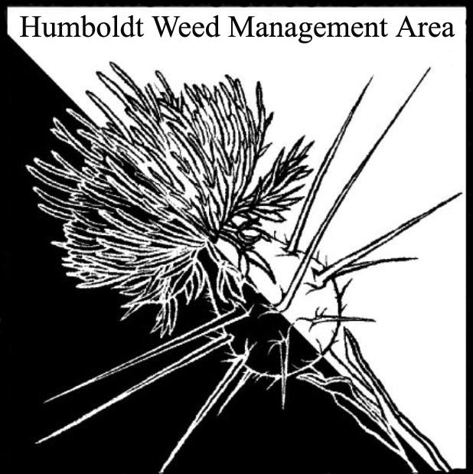

- Welcome
  - Attendees: Crystal Welch (BLM), Scott Estepa (BLM), Jenna Camenson (BLM), Gabe Cashman (GDRCo), Veronica Yates (Native Ecosystems), Justyna Marszalek (Yurok Tribe Fisheries), Patrick Hoffman (CAC), David Juliano (CAC), John Hackett (Caltrans), Christina Cortez (MRC), Trevor Fox (State WMA liaison), Melyssa Spandri (Trinidad Rancheria), Carl Klarner (RIPE)
  - Discussion of meeting minutes brought up by Carl. Patrick suggested secretary position. Crystal suggested volunteer note-taking, Patrick seconded.
  - Patrick announced he will be stepping down as chairperson due to change of work duties. Patrick nominated David as co-chair; Crystal seconded, John third, carl fourth. Susannah to remain as co-chair.
- MOU and renewed Statement of Ongoing Affirmation
  - The current MOU expired August 11, 2019. Far expired but have not updated the MOU. Discussion about needing a 5 year expiration for a MOU. Patrick will send an updated draft MOU to provide a comment period. Will be a working group for the MOU. Has to be signed by board of Supervisors. Once completed it will be signed by the head of each representing agency. We need a current MOU prior to billing for the Eel grass HWMA state project. MOUs need to be updated within 6 months of WMAGP grant date (June 15th).
  - Patrick asked MRC for update on Eel Grass project and billing details. MRC will get back with updates when staff return from field work
- County Fair Table
  - HWMA group has an educational table at the fair showcasing local weeds. Will need sign up for sample collection, set up, manning table, watering plants, and takedown
  - County Ag has tablecloths and tables. NPS has display board.
  - There is a category of participation under education that is non-competitive, normally we participate under a competitive category, discussion of change
  - Patrick will update Google Doc with the time/dates and will send follow up email relinking the Google Doc
- Round Robin
  - CAC - Pulling spotted knapweed on sites on Mattole road and Mad River. Did a recent release of cinnabar moth for tansy ragwort on Woodley Island; prior attempt was not successful on island but some success in Bear River. Discussion of lack of success of the cinnabar moths in Humboldt County. Successful in Del Norte and parts of Mendocino. Recently alerted to gorse site on Danco property in Samoa; Danco excavated, CAC will continue to monitor site.
  - Cal Trans – removal of tansy ragwort, mapping of shiny geranium sites
  - HRC - Shively project: thinning for fire fuels reduction; herbicide application for poison hemlock, Himalayan blackberry and annual grasses. Herbicides used: trichlopyr, milestone, glyphosate and oust
  - BLM - Scotch broom, French broom, Pampas grass and thistles being treated on BLM lands. Monitoring on Lost Coast Headlands.
  - State Parks - Wrapping up EDRR surveys for the year. Conducted at Prairie Creek RSP and multiple in State Parks in Mendocino County. Conducting purple loosestrife removal this month in Humboldt Redwoods SP. New spiderwort infestation found near Miranda being treated. Treatment of broom and other invasive species in the prairies in Humboldt Redwoods SP with the help of a Student Conservation Association crew. Most work in the last 3 months have been in Del Norte and Mendocino counties.

