HWMA Meeting
Tuesday, January 28, 2025
Arcata BLM/Zoom Hybrid Meeting
1:00 – 2:30 p.m.

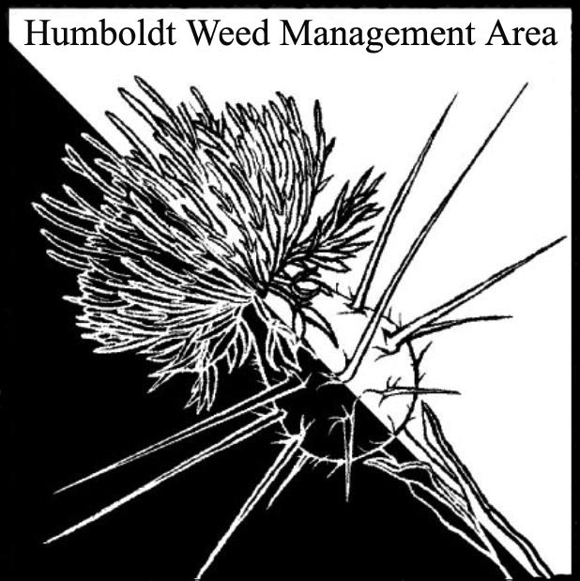

- Welcome – Introductions/April Minutes Approval
  - Attendees: Crystal Welch (BLM), Patrick Hoffman (CAC), Susannah Ferson (RCAA), Mike Cipra (RCAA), Carl Klarner (RIPE), Jane Dexter (MRC), Michelle Forys (CSP), James Ray (CDFW), Gabe Cashman (GDRCo), Sarah Conway (NPS), Justyna Marszalek (Yurok Tribe Fisheries), Molly McSweeney (USDA NRCS), Melissa Spandri (Trinidad Rancheria), and Ethan Donoghue (HRC).
  - October 2024 minutes were approved, with one small change.

- Opening announcements
A. GRANT PROPOSAL

We’re hoping that the CDFA funding becomes more regular. Some of us met on both January 2 and January 8 to discuss possible grant proposals. Grant funds can’t be used for CEQA compliance, so we decided that a mapping project would be best. Japanese eelgrass is a CDFA A-rated invasive species, is on the HWMA red alert list, and Susannah has experience mapping/controlling it. There was a Zostera japonica mapping control project through Ca Sea Grant and CDFW years ago, but funding dried out and not much has happened since then. RCAA will apply for the maximum award of $40,000 a year for three years to map the extent of japonica in Humboldt Bay and Gannon Slough. MRC will provide a drone to determine the density of Spartina growing in association with japonica. BLM will provide assistance with GIS work, utilizing their in-house GIS expert.

B. PLAN FOR UPDATING THE HWMA WEEDS PRIORITY LIST

The working group agreed that the HWMA weed prioritization list should be updated. The last full update might have occurred in 2020. To update the list, Susannah suggested we need to better define criteria and create a standard process to best rate listed plants. Patrick proposed creating a point system. Patrick reminded the group that CalIPC has the definitions of their criteria on their website. These are based off reviews of concerns with the species. One thing we could do is take CDFA and CalIPC ratings and quarantine lists from Oregon and Washington and assign points to those. We could combine these with information about what is being treated locally to create our scores. Michelle Forys mentioned that there may be things that should be on our list because they are a big concern elsewhere in California, but are just getting here, for example stinkwort. However, there are plants in our area that aren’t on the state list, and we should be careful to include those. We’ve seen things that aren’t on CalIPC’s radar, and then years later they become invasive.

Michelle will chair a subcommittee tasked to update the list. She will send out an email asking whether people would like to be on the subcommittee and/or whether they wish to add any new species to the list. Sussanah and Patrick will update the CDFA and CalIPC ratings between them. The committee will examine new plants that CalIPC is concerned about and consider their local impact. There was a consensus that the list should be publicly accessible, posted on the HWMA website, and shared with WMAs in neighboring counties. Grant writers who aren’t tied in with the HWMA benefit from being able to easily reference which invasive species are of concern in our area.

C. SUBCOMMITTEE ON HERBICIDE USE

The subcommittee on herbicide use has met a few times. The goal of the subcommittee is to provide a non-biased perspective on herbicide use in Humboldt County, although we haven’t decided if a brochure vs other type of outreach would best convey the information. Topics may include a brief discussion of adaptive management practices, the evolution of chemicals used since the 1970s, regulations of those chemicals, etc. We had discussed highlighting some successful local projects, but we backed away from this idea because we don’t want to draw attention to individual projects. We decided to keep it more informational, by addressing commonly asked questions.

Most partner agencies only use a couple of herbicides, and they are extremely targeted and mild. A partner commented that a lot of research has been done on the herbicide they use, and they are confident that it doesn’t do ecological harm. But their knowledge of this one herbicide doesn’t allow them to sign off on different herbicides used by other weed managers. The outreach is not meant to inform the public on what they should or should not do on their property.

There was consensus that HWMA agencies are far more limited in the herbicides they can use than what members of the general public can purchase almost anywhere. There was general agreement that many people aren’t going to be sympathetic with herbicide use no matter what, so the brochure should be targeted at those who have genuine questions about its use. The committee will bring any drafts of a brochure to the group for edits/comments.

- Round Robin

Crystal Welch (Blm)
BLM just purchased a property called Lost Coast Redwoods. There is gorse there and we are working to eradicate it. A question was asked about where specifically the gorse is, and Crystal will send out more information. It’s by Usal Road, near Usal Beach.

Mike Cipra (RCAA)
Continuing partnership with USFW and Friends of the Dunes on coastal dune habitat restoration at Ma-le’l and Lanphere Dunes, and Samoa Dunes.
Lots of crews working out there, getting a lot done. We saw MRC out there also.
Going to have an extensive planting across all the properties in the winter of 2025.

Susanah Ferson (RCAA)
Still eradicating spartina on Tuluwat Island, we are trying to get as much work done as possible before nesting bird season starts. There are other areas around the bay aside from Tuluwat Island we’ve been treating. Want to re-treat the Elk River site.
Former Humboldt Bay National Wildlife Refuge Manager (Eric Nelson) contacted us recently, wants to work with the city of Eureka to deal with seeds that are washing into a newly restored site off Elk Island.

Patrick Hoffman (County Agriculture)
Not much going on right now. Staff is down. Several new shiny geranium sites have been found. It is beyond our resources to attempt control at this point.

Carl Klarner (RIPE)
Work continues, lots of events, we are up to about 1,700 volunteer hours in the last two years.

James Ray (CDFA)
In August, applied herbicide and had controlled fires on the dunes at Ocean Ranch, treated 80 acres in total this year. We’ve had a number of hand pulling events to take care of leftover infestations after herbicide and controlled fire treatments. We also treated half an acre in that area, the Wiyot Cultural Garden. We did plantings of culturally important plants to the Wiyot people. We eradicated poison hemlock and radish there.
Feb 28: day of weed whacking coming up at Ocean Ranch, will email about that.
Spartina treatment with MRC, we will contract out to them, and hopefully that will start in February.

Jane Dexter (MRC)
Just finished 4 month “duffing project” with RCAA at Lanphere Dunes. Sand fences will control the movement of sand which will aid native plants. Harvesting grass plugs. Replanting them in the dunes. We took about 36,000 from areas where they are already abundant.

Gabe Cashman (GDRCo)
We continue to monitor spotted knapweed by the Mad River and star thistle in the Bald Hills. Taking out Scotch broom in higher conservation value areas, using weed wrenches or by hand.
Patrick: what happened with the gorse biocontrol?
Spider mites and weevils are still active on the landscape, which is good. Grose thrips does not appear to have established.

Ethan Donoghue (Humboldt Redwood Company)
Stinkwort infestation by the railroad authority: we’re continuing to monitor it.
Barbed goat grass on Kneeland: watching that.
Patrick: There is also shiny geranium in Kneeland, so watch out for that.

Michelle Forys (CSP)
Treating a lot of beachgrass, concentrate on this in the winter when there aren’t snowy plovers nesting. Completed 22 acres at Little River. We’re going to transplant dune plants next fall with seeds collected by Samara Restoration. Currently, we’re planting some plugs to keep the sand from moving onto an ADA trail. Gold Bluff beach project delayed because CCCs aren’t available. Have had a lot of ivy removal volunteer events. Treating ice plant at Big Lagoon.
A few prescribed burns at Humboldt Redwoods, at Dolason Prairie, and also Prairie Creek. Planning a controlled burn at Humboldt Redwoods State Park. We are ready to go after invasives that emerge after these prescribed burns, such as Scotch broom and a couple different grasses.

Melissa Spandri (Trinidad Rancheria)
We’ve put out a request for a proposal for a native habitat restoration project. We are looking to hire a contractor to eradicate English ivy, invasive blackberries, and some other invasive plants. Use of herbicides is prohibited.

Sarah Conway (NPS)
I’ve been working on English ivy, Scotch broom and Himalayan blackberries.
We are drawing help from our state park partners and hoping we can get all of our work covered.

Molly McSweeney (USDA NRCS)
Monitoring invasive grasses & planning on doing a burn.

- Closing announcements
  - Michelle: Can we send out the meeting minutes far in advance of the next meeting? That would make it a lot easier to make the changes and approve the minutes.
  - Next HWMA meeting is set for April 8, 2025
from 1 – 2:30 p.m. Arcata BLM/Zoom Hybrid Meeting

