HWMA Meeting Minutes
Monday, December 8, 2025
Arcata BLM/Zoom Hybrid Meeting
1:00 – 2:30 p.m.

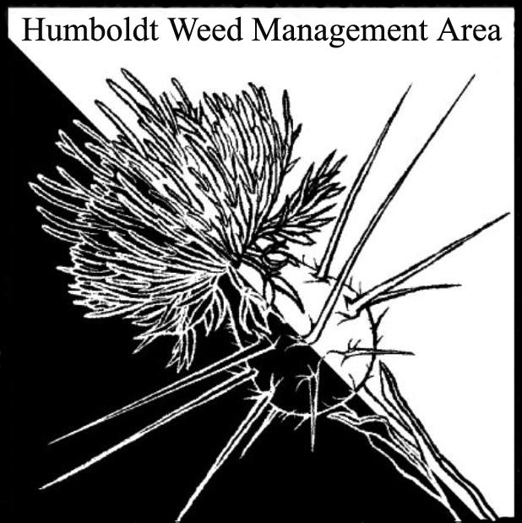

- Welcome
Attendees: Jenna Santangelo (RCAA), Scott Estepa (BLM), Crystal Kunz (BLM), Gabe Cashman (Green Diamond), David Juliano (HumCo Ag), Patrick Hoffman (HumCo Ag), Carl Klarner (RIPE), Michelle Forys (State Parks) Megan Gollehon (State Parks), Melyssa Spandri (Cher-Ae Heights), Christina Cortez (Mattole Restoration Council), Kimberly Davis (Hoopa Tribal Forestry), Justyna Marszalek (Yurok Fisheries), Hannah Atwood (City of Eureka)

- July Meeting Minutes Approved
- HWMA Co-Chair Position
  - David Juliano from Humboldt County Department of Agriculture was introduced as the new chair, taking over for Patrick. David was elected to this position during the July 2025 meeting.
  - Susanna Ferson has left RCAA and stepped down from her HWMA co-chair position, so a request was made for a volunteer to step in as the new co-chair. Michelle, who has been involved for nearly 30 years, expressed interest in supporting the transition but noted her busy schedule, while Megan, her field lead, was suggested as a potential co-chair. The position remains open, with the group deciding to revisit the topic at the next meeting.

- Priority Weed List
The group discussed the need to complete updates to the weed management area priority list. Species on the existing list were reviewed during previous subcommittee meetings. Michelle clarified that the status of existing listed taxa will not be further discussed, but that potential new additions still need to be reviewed. The group agreed to hold another subcommittee meeting

- Website Updates
The group discussed updating the HWMA webpage, with Patrick noting that Susanna previously handled updates. Login information will likely need to be obtained from her or Cal-IPC.

- Memorandum of Understanding (MOU)
The current MOU, which expired in 2019, was reviewed. The group discussed the need to create a new MOU. Individual signatory pages will be needed for easier routing to potential partners. It was agreed that a smaller working group would be better suited to tackle these updates outside of regular meetings, with the goal of potentially revisiting the documents at the next quarterly meeting. Michelle suggested forming a subcommittee to review and update both the MOU and bylaws, as they may need revisions to reflect recent organizational changes. Carl, Michelle, Patrick, Scott, and David volunteered to participate. The group agreed to collaborate on revising the MOU through a shared document, with Crystal offering to help and suggesting they work on it after the new year to avoid scheduling conflicts. Patrick offered to share any relevant files and potentially set up a Google Drive for document sharing.

- Round Robin

  - HumCo Ag – Spotted knapweed removal continues near Blue Lake. Treating knotweed at the airport and in county ROW sites from just south of Eureka to just north of Sue-meg since 2018. All sites are finally clear. Cinnabar moth releases on Woodley Island for tansy ragwort control last summer.
  - GDRCo – Continuing annual spotted knapweed removal on the Mad River. Treated yellow star thistle in the Bald Hills last spring. Continuing to treat gorse sites chemically. Gorse biocontrol did not establish.
  - BLM (Scott) – Interns mapping Ammophila resprouts at Ma’lel Dunes.
  - RCAA – Continuing work on Tuluwat and at the dunes.
  - MRC – Invasive removal in the King Range, including tansy ragwort, Scotch broom, French broom, and Pampus. There is a small but growing population of Japanese knotweed on Lighthouse Rd. Working alongside RCAA on dune restoration.
  - BLM (Crystal) – Ongoing work with MRC. Incorporating heavy equipment for trenching and burying beach grass and other invasives. Incorporating prescribed fire to reduce fuel loads and above ground biomass. Partnering with Trinidad Coastal Land Trust on managing invasives on Trinidad Head. Partnered with Friends of the Dunes as they continue their monthly Dert Days at Ma’lel Dunes.
  - State Parks – In winter, largely focused on beach grass and ice plant at Gold Bluffs Beach, Little River State Beach, and Humboldt Lagoons State Park. Lots of prairie restoration at Humboldt Redwoods with broom, annual grasses, oxide daisy, thistles, blackberry. Also treated the stinkwort site at Humboldt Redwoods SP.
  - RIPE – Carl personally put in 263 hours of invasives work. Other volunteers put in another 340 hours. Removing ivy and holly at Cooper Gulch and McKay Community Forest. This work creates a lot of green waste, which is hauled off site. Considering alternative ways to deal with this waste. Adopted a section of hwy 101 with significant ivy infestations. Visited 104 private residences to remove ivy.
  - City of Eureka – Continuing to work with Carl, who has become one of the city’s volunteer coordinators. Also continuing Ivy League removal days in Sequoia Park. Nearly 10,000 lbs of ivy removed in 2025. Slough restoration work at Cooper Gulch will increase access to invasives being removed.
  - Hoopa Tribal Forestry – Hoopa fisheries department is trying to incorporate weed management into their future planning. Kim has been trying to educate people on invasives in their own yards.

- Closing announcements
HWMA spring meeting will be held on April 21 from 2-3:00 pm

