**HWMA Meeting**

Tuesday, October 8, 2024

Arcata BLM/Zoom Hybrid Meeting

1:00 – 3:00 p.m.

**Draft Minutes**

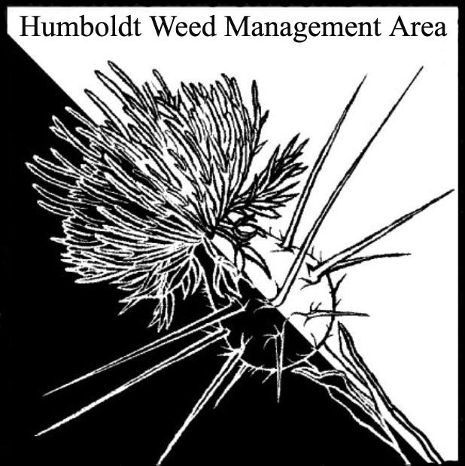

1. **Welcome – Introductions/April Minutes Approval** 
   1. Attendees: Crystal Welch (BLM), John Hackett (Caltrans), Patrick Hoffman (CAC), Susannah Ferson (RCAA), Shea McDonald (Yurok Tribe Fisheries), Kelsey McDonald (CDFW), Emily Afriat (The Wildlands Conservancy), Scott Estepa (BLM), Carl Klarner (RIPE), Jane Dexter (MRC), Michelle Forys (CSP), Sarah Conway, Justyna Marszalek (Yurok Tribe Fisheries), Molly McSweeney (USDA NRCS), Elben Andrews (MKWK), Gabe Cashman (GDRCo), Stephen Underwood (CNPS), Hannah Atwood (City of Eureka), Kimberly Davis (Hoopa Tribe, Tsemeta Nursery Manager)
   2. July minutes were approved.
2. **Opening Announcements**

* **Oct. 23** – Online **Statewide WMA Meeting**, 8:30-10:30 am. [Register here](https://us-east-2.protection.sophos.com/?d=neoncrm.com&u=aHR0cHM6Ly9jYWxpcGMuYXBwLm5lb25jcm0uY29tL25wL2NsaWVudHMvY2FsaXBjL2V2ZW50UmVnaXN0cmF0aW9uLmpzcD9ldmVudD05MSY=&i=NjE0ZjQ3OGMyMGE1NTkwZTYyYzQxMjAz&t=UnpmU2xPSmFRTFg1TjVpZGZDNHBRbnd6N1FvS3I4MHlxempRbmc5bHQzVT0=&h=bf94d4abf7844ec7ae52f7628e52b949&s=AVNPUEhUT0NFTkNSWVBUSVaVsw_KCb41zeNaSv6P90fkYGp9C83kOjzUTED4AvmIBQ) (select “WMA Meeting only”). The event is free.

* **Oct. 23-25** – Online **2024 Cal-IPC Symposium**, “Getting Ahead of the Invasion Curve,” with presentations, workshops, career panel, and more.  [Information here](https://us-east-2.protection.sophos.com/?d=cal-ipc.org&u=aHR0cHM6Ly93d3cuY2FsLWlwYy5vcmcvcmVzb3VyY2VzL3N5bXBvc2l1bS8=&i=NjE0ZjQ3OGMyMGE1NTkwZTYyYzQxMjAz&t=UmJ2WDhZc3JQVDJGZ045dm5Oc3pRWm05VEZ2ZmF0c3F5L3ByN0VKOVRpYz0=&h=bf94d4abf7844ec7ae52f7628e52b949&s=AVNPUEhUT0NFTkNSWVBUSVaVsw_KCb41zeNaSv6P90fkYGp9C83kOjzUTED4AvmIBQ). [Register here](https://us-east-2.protection.sophos.com/?d=cal-ipc.org&u=aHR0cHM6Ly93d3cuY2FsLWlwYy5vcmcvcmVzb3VyY2VzL3N5bXBvc2l1bS9yZWdpc3Rlci8=&i=NjE0ZjQ3OGMyMGE1NTkwZTYyYzQxMjAz&t=ZjdNVWVCWWtTK2lJT3Y1MVhmQXRjR2thTThTMW1XWTNyd3I3Ri9pK25jMD0=&h=bf94d4abf7844ec7ae52f7628e52b949&s=AVNPUEhUT0NFTkNSWVBUSVaVsw_KCb41zeNaSv6P90fkYGp9C83kOjzUTED4AvmIBQ). There is a registration fee.

* **Nov. 15** – In-person **Cal-IPC NorCal Practitioner Workshop** at Cal State East Bay in Concord. [Information and registration here](https://us-east-2.protection.sophos.com/?d=cal-ipc.org&u=aHR0cHM6Ly93d3cuY2FsLWlwYy5vcmcvd29ya3Nob3BzLw==&i=NjE0ZjQ3OGMyMGE1NTkwZTYyYzQxMjAz&t=dE02UXpOUVhGUVQyeGlpUy8wYlo1ODRzNzJaaXhuWU1zeDVRZlBINk9UYz0=&h=bf94d4abf7844ec7ae52f7628e52b949&s=AVNPUEhUT0NFTkNSWVBUSVaVsw_KCb41zeNaSv6P90fkYGp9C83kOjzUTED4AvmIBQ). There is a registration fee.

1. **Subcommittee on Herbicide Use – Update**

Discussion to form this subcommittee occurred in July, but no meetings have been held. It was clarified that the subcommittee's purpose was not to advocate for or against herbicide use, but to address various questions from different organizations related to herbicide use for control of noxious weeds and why this method may be chosen. Emily agreed to send an email to the group about the subcommittee and asked for direct responses from anyone interested in participating.

1. **Round Robin**

Gabe Cashman (GDRCo) – Annual removal of spotted knapweed from site on the Mad River occurred—only 12 plants remain. Yellow star-thistle herbicide treatments in the Bald Hills were made ahead of Calfire burns. Hand removal of Scotch broom along Christmas Creek. Pampus grass from GDRCo property was sent to USDA Albany lab to be used for biocontrol rearing.

Stephen Underwood (CNPS) – Rohnert Park ivy removal work continues.

Scott Estepa (BLM) – Scotch broom removal on multiple BLM properties. Pampus grass removal on lost coast headlands. 1.4 tons of ivy was removed in three hours at Trinidad ivy pull in September.

Jane Dexter (MRC) – Wrapping up invasives work in the King Range. Working on Lanphere Dunes, including hand removal of duff build-up. Invasive removal scheduled for the Table Bluff reserve as part of efforts to protect the Western Lily population there.

Crystal Welch (BLM) – Revisiting sites previously treated and getting to sites not visited for a while. Coordinating with Humboldt Community Services District on pipeline mitigation work.

Carl Klarner (RIPE) – Discussed invasive removal efforts over the past three months: removed ivy from approximately 578 trees. Highlighted RIPE’s free service of removing fruiting ivy from private properties. Working with Humboldt Creamery to remove fruiting ivy from their property. Creating a webpage listing businesses that cooperate with invasives removal.

Kelsey McDonald (CDFW) – Successful treatment of over 80 acres of European beach grass at Ocean Ranch. Will burn treated areas. Plan to pull invading Scotch broom. Treating Spartina with brush trimmers. Pilot project testing control strategies for reed canary grass at an inland fen.

Michelle Forys (CSP) – Finished annual purple loosestrife cutting/pulling efforts on the south fork of the Eel. Numbers have decreased compared to last year. Starting beach grass work soon and ice plant removal on the dunes. The CEQA comment period will be open soon for a joint State Parks and Caltrans restoration project using targeted herbicide treatments. Partnered with Pull Together Trinidad on ivy removal. Saw an increase in oxeye daisy at Humboldt Redwoods this year. Treated with herbicide and fire. Spiderwort infestations close to being eradicated. EDRR surveys ongoing at several locations.

Elben Andrews (MKWK) – Monitoring and mapping invasives on burned land. Pulling puncturevine on the Trinity and Klamath rivers. Pulling dyer’s woad, oblong spurge, sulfur cinquefoil, on the Klamath. Stinkwort is present on the Trinity but has not been found on the Klamath.

Emily Afriat (The Wildlands Conservancy) – Worked with a group of high schoolers from Southern California who participated in restoration work at Seawood Cape Preserve. This is an annual program. Eight plus truckloads of ivy were removed, plus heath and other invasives. Before Emily’s time with The Wildlands Conservancy, Jubata grass had been treated with herbicide. It is still a major problem and they have considered returning to herbicide use. Fertile capeweed in the Eel River estuary appears to have been outcompeted by grasses after the August rains. Spartina in the Eel River estuary is being treated by RCAA.

Hannah Atwood (City of Eureka) – Ivy league’s work is ongoing. Thirty-three attendees in September removed ivy and planted native plants. Wes Green is no longer taking ivy, so another disposal method had to be found. Ivy will be moved offsite for consumption by goats. Working with CCC’s to remove invasives in Cooper Gulch.

Shea McDonald (Yurok Tribe Fisheries) – Orick Mill site restoration is on-going. Currently treating Canada thistle at Mill using Transline. Completed Canada thistle treatments at Iron gate and other dam restoration sites.

Justyna Marszalek (Yurok Tribe Fisheries) – Discussed garlic mustard in Trinity County. Only known to be spreading along a single stream, but little has been done to determine the extent of its spready in the region. Seeking funding to treat the infested area. Discussed gravel as a concerning vector of weed spread and the desire for weed-free gravel.

Sarah Conway (NPS) – New member, was welcomed to the group, replacing Laura Julian who retired from Redwood National and State Parks. NPS recently finished harding grass treatments in the Bald Hills. EDRR ongoing at burned sites. Girdling ivy and using “buckthorn blasters” application tools with roundup custom to chemically treat.

Kimberly Davis (Hoopa Tribe, Tsemeta Nursery Mgr) – Busy with cone collection for the nursery. Discussed Tree of Heaven’s continued spread in Hoopa and the use of a fungal pathogen (*Verticillium nonalfalfae*) in the eastern US to control it.

1. **Closing announcements** 
   1. Next HWMA meeting is set for January 28, 2025

from 1 – 2:30 p.m. Arcata BLM/Zoom Hybrid Meeting