**HWMA Meeting**

Tuesday, July 9, 2024

Arcata BLM/Zoom Hybrid Meeting

1:00 – 2:30 p.m.

**Draft Minutes**

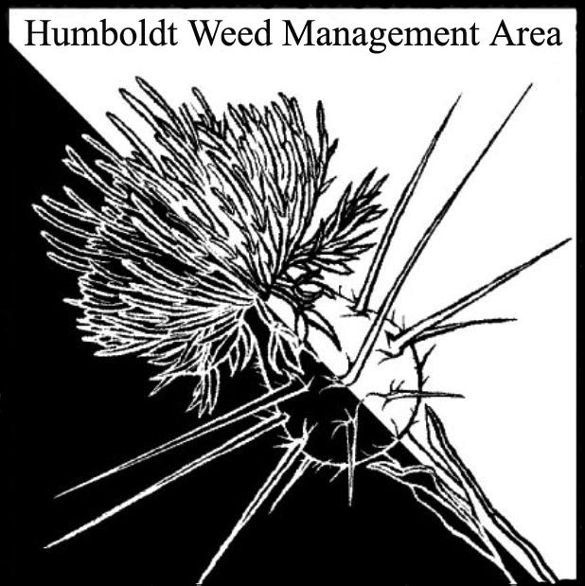

1. **Welcome – Introductions/April Minutes Approval** 
   1. Attendees: Patrick Hoffman (Humboldt CAC), Susannah Ferson (RCAA), Laura Julien (NPS), Kim Davies (Tsemeta, Hoopa Tribe), Emily Afriat (The Wildlands Conservancy), Scott Estepa (BLM), Carl Klarner (RIPE), John Hackett (Caltrans), Jane Dexter (MRC), Tarah Balden (Yurok Tribe), Hannah Atwood (City of Eureka), Elektra Mathews-Novelli (Yurok Tribe Fisheries), Trevor Fox (CDFA), Justyna Marszalek (Yurok Tribe Fisheries), Morguine Sefcik (City of Arcata), Todd Golder (USDA NRCS), Molly McSweeney (USDA NRCS)
   2. April minutes were approved. Susannah will post minutes to the Cal-IPC Humboldt WMA webpage.
2. **County Fair Display**

Volunteers are needed for set-up/tear down and weed collection. Carl, Jane, Scott, Emily, and Laura volunteered. Patrick will send out an email with details and a link to a Google Docs sign-up sheet. Laura said she could bring the NPS display board down from Orick.

1. **Cal-IPC HWMA Webpage Update**

Susannah has been working on updates. She requested that anyone with a project that they are interested in highlighting send her a short summary to post.

1. **MOU Updates**

Susannah is in the process of updating MOU signatory contacts and other organization information. Susannah and Patrick will reach out to inactive organizations to confirm continued interest in membership.

1. **Round Robin**

Scott Estepa (BLM) – Working on Ammophila removal on the South Spit.

Emily Afriat (TWC) – Hand pulling and mowing heath and ivy at the Seawood Cape Preserve and Spartina and thistle at the Eel River Estuary Preserve.

Laura Julien (NPS) – Ice plant sweeps and Ammophila removal on beaches and at Freshwater Lagoon. Ammophila was treated with herbicide a few years ago. Areas previously cleared have seen Ammophila reintroduced by major tidal/wave action during winter storms. Treating shining geranium and herb-robert sites; brooms and acacia in Hiouchi; brooms, oxeye daisy, blackberry, and harding grass in the Bald Hills.

Kim Davies (Tsemeta, Hoopa Tribe) – New manager of Tsemeta Forest Nursery, has been Hoopa Tribal Botanist for years. Currently focused on the nursery. Concerned about Tree of Heaven, but control is difficult and chemical treatment is not allowed in Hoopa.

Susannah Ferson (RCAA) – Wants to bring back the idea of a subcommittee on herbicide use. Will send out an organizing email to those interested in participating.

Carl Klarner (RIPE) – RIPE members have been joining Volunteer Trail Stewards events. Plan to participate in ivy removal at the Arcata Marsh. Have been working on ivy control on property operated by Eureka City Schools. Would like to cut ivy at roosts on Tuluwot at an appropriate time to avoid disturbing nesting birds. Suggested direct mailers for tree of heaven outreach.

John Hackett – Has been on the lookout for tansy ragwort. After two years of pulling tansy at the 36/101 interchange, it is gone. Has noticed tansy on Woodley Island. Tree of heaven continues to spread along 101 in Garberville.

Jane Dexter (MRC) – Completed two, four-day backpacking trips to remove invasives on the King Range. Targeted Italian thistle and Pampus grass. Tansy removal is ramping up. Removing Ammophila on the South Spit. Removing yellow bush lupin at Lanphere dunes. Participating in Petrolia community scotch broom pull.

Hannah Atwood (City of Eureka) – Sequoia Park Ivy League continues to be active with 15-20 volunteers at most events. The city has been working on foxtail removal at dog parks. Checked with Donald Wilkes, Harbor Operations Superintendent, on the status of the gorse on the Hikshari trail. He said it has been treated.

Justyna Marszalek (Yurok Tribe Fisheries) – Multiple river restoration projects underway, including the Gateway project.

Tarah Balden (Yurok Tribe) – The new invasive species coordinator for the Yurok Tribe. Working on mapping and controlling scotch broom and geraniums. Working on fostering collaboration between tribal departments and data sharing.

Morguine Sefcik (City of Arcata) – Working with RCAA on invasives removal. Pulling shining geranium. Invasive species week press release sent out in June. This is done annually, the HWMA is invited to contribute in future years. Working on plans to remove sponge plant at the Arcata Marsh.

Patrick Hoffman (Humboldt CAC) – finished hand pulling shining geranium at two previously known Eureka sites. Five additional sites were found this spring/summer: Coast Guard Plaza in Eureka, Trinidad area at private home, West End Road, Kneeland, South Fork Campground on 299. Begun pulling spotted knapweed at sites on the Mad River and Mattole Road and tansy ragwort on Woodley Island.

Todd Golder (USDA NRCS) – Barbed goat grass is spreading on rangelands from Ft. Seward to Bridegville and towards Maple Creek, leading to a 50 – 75% loss in grazing capacity on invaded lands. NRCS is treating with burning and re-seeding. Anyone interested in more information should reach out to Molly McSweeney with NRCS.

Trevor Fox (CDFA) – WMA grant funds are still expected to be released this summer.

1. **Public Outreach Discussion**

Public invasive species outreach ideas were discussed, first focused on outreach surrounding the invasiveness of tree of heaven and then on invasive species in general. Susannah suggested creating a Tree of Heaven outreach subcommittee. Jane and Carl suggested direct mailers. Scott suggested purchasing a billboard or making tree of heaven a focus of the county fair display this year. Hannah offered to include invasive species information on City of Eureka social media posts/newsletters. Carl also brought up the idea of an app for invasive species mapping. Patrick suggested creating an invasives focused iNaturalist.org project, just as Kings County and other invasives groups have done. Scott described the Wild Spotter app, which was specifically designed for the public to document invasives. No decision was made on next steps as time and funding seem to be barriers.

1. **Closing announcements** 
   1. Next HWMA meeting is set for Tuesday, October 8, 2024

from 1 – 2:30 p.m. Arcata BLM/Zoom Hybrid Meeting