**HWMA**

**Committee Meeting**

Tuesday, July 11, 2023

Arcata BLM/Zoom Hybrid Meeting

1:00 – 2:30 p.m.

**Draft Minutes**

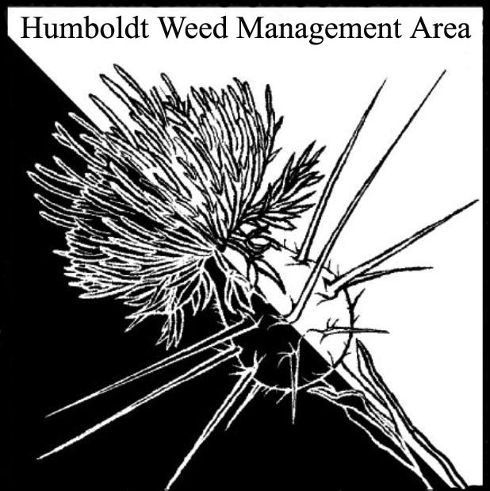

1. **Welcome/Sign-in**

Zoe Ziegler (TCLT), Crystal Welch (BLM), Ethan Donoghue (HRC), John Hacket (Caltrans), Andrea Pickart (USFWS), Susannah Ferson (RCAA), Patrick Hoffman (CAC)

1. **County Fair HWMA Table**

Discussed the annual HWMA Humboldt County Fair invasive weed table. A Google doc sign-up sheet will be sent out for anyone interested in helping with collection of weed samples or display set-up.

1. **Follow-up on herbicide use in Humboldt County (planning)**

Continued planning discussion for an informational meeting on herbicide use as a tool for invasive weed control. Crystal Welch suggested developing a fact sheet on the top three herbicides used by local land managers.

1. **Round robin**

**John Hackett (Caltrans)** – Caltrans is returning to their initial approved chemical program from 1992 and developing a new review process for adding pesticide products. AB 99 is an on-going item of concern. Mulching shiny geranium with wood chips at the 299 site is proving effective at reducing the population. Will begin mulching at the 101/Klamath Bridge site.

**Andrea Pickart (HBNWR)** – Partnering with FOD to treat Ammophila and yellow bush lupin on FOD managed land and on the Wadulh Unit north of Lanphere. Currently applying for additional grant funds. Some herbicide use will occur on foredunes while manual removal will occur on back dunes. Heavy equipment will be used in some areas. Drone monitoring to map dune changes is ongoing.

**Susannah Ferson (RCAA)** – Spartina work is beginning on Tuluwat. Work continues on the Jacoby Creek and Hookton Slough units. Plan to treat knotweed sites in fall. Working with USFS to inventory invasives at the site of the Lightening Fire Complex.

**Crystal Welch (BLM)** – Under agreement with the Bear River Band of the Rohnerville Rancheria to create new interpretation signs with cultural and invasive species aspects. Will include QR codes, allowing people to submit plant phenology data. Treated three acres of Ammophila on the south spit. BLM will be funding MRC crew to work in the King Range Conservation Area long term. **Patrick Hoffman (CAC)** – Nearly done with tansy ragwort removal on Woodley Island and spotted knapweed pulling at sites near Blue Lake and along Mattole Rd. RCAA crew assisted with pulling tansy across 16 acres. Arcata resident reported biddy biddy (Acaena novae-zelandieae) on their property. Historically was present near McKinleyville and was treated via herbicide application for many years. Will be talking to the homeowners and potentially tarping the site. Biddy biddy is a problem invasive of dunes in the UK.

1. **Closing announcements**

a. Next meeting set for Tuesday, October 10, 2023

from 1 – 2:30 p.m. Location TBD