**HWMA Meeting**

Tuesday, January 9, 2024

Zoom meeting

Arcata BLM/Zoom Hybrid Meeting

1:00 – 2:30 p.m.

**Meeting Minutes**

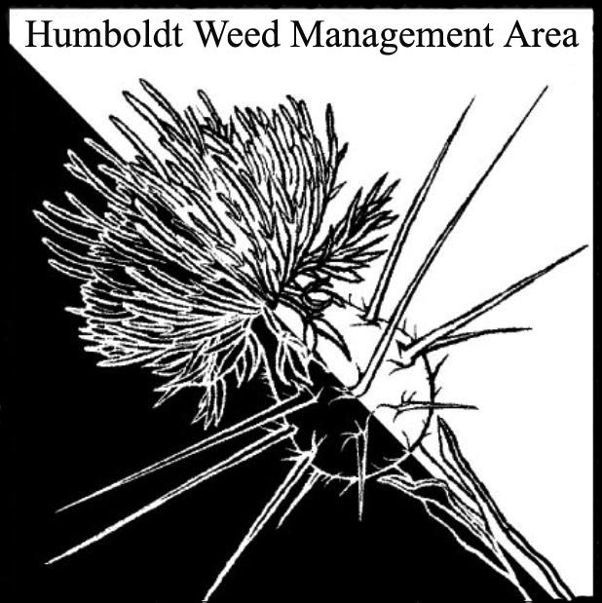

1. **Welcome – Introductions**

Carl Klarner (Independent), Steven Underwood (CNPS), John Hackett (Caltrans)

Michelle Forys (CSP), Laurel Goldsmith (USFWS), Owen Bardsley (BLM), Patrick Hoffman (CAC), Morguine Sefcik (City of Arcata), Susannah Ferson (RCAA), Laura Julian (NPS)

1. **Upcoming CDFA funding for Weed Management Areas**

No call for grant proposals yet, but CDFA hopes to be contracted with WMAs by July of this year. When the call for proposals is announced a special meeting will be scheduled to discuss. Susannah Ferson described the process the last time similar grants were made available: a meeting was called where members presented potential projects, which were then voted on by the steering committee. The HWMA MOU may describe the process. Several members agreed to review the MOU before the next meeting.

1. **Change to future January meetings**

Patrick Hoffman and Susannah Ferson discussed having noticed reduced attendance at January meetings, typically held on the second Tuesday of the month. Members agreed to hold future January meetings on the last Tuesday of the month to reduce conflicts with holidays/vacations.

1. **Round Robin**

**Patrick Hoffman (CAC) –** Will begin third year of shiny geranium work at Eureka sites soon. Saw a major reduction of shiny geranium at Fairway Drive site between first and second years of hand pulling.

**John Hackett (Caltrans) –** Shiny geranium populations exist scattered along 101 from the Oregon border to northern Mendocino, where a single known population is present on highway 1. Caltrans has considered leasing steaming equipment to treat geranium but would need another agency to operate the equipment.

**Laurel Goldsmith** **(USFWS)** – Continues to track star mustard (*Coincya monensis*) on FOD property and private properties off Lincoln Ave.

**Stephen Underwood (CNPS)** – Monthly Rohner Park ivy pull continues every third Saturday at 9:00 am.

**Owen Bardsley (BLM)** – Clearing Ammophila on the south spit. Continued removal of multiple invasives at Samoa Dunes. Removing ornamental roses, cape-ivy, and other invasives on Trinidad Head before replanting with native plants.

**Susannah Ferson (RCAA)** – Spartina treatment on Tolowat is fifty-percent complete. Working on various Spartina maintenance projects. Will be focusing on Hookton Slough next. Working under three grants to fund RCAA staff, CCC, and ACE to remove Ammophila and *Lupinus arboreus* from Friends of the Dunes property north to border with Mad River County Park. Will be using heavy equipment to bury lupin.

**Michelle Forys (CSP) –** Spraying shiny geranium in Del Norte. Will be retreating Ammophila in January/February on Gold Bluff Beach and initially treating Ammophila at Little River Beach using heavy equipment. Scarping at Little River has led to deposition of Ammophila onto the restoration project area for two years in a row. This is a new problem, not seen before the last couple of years. Prairie restoration projects continue at Humboldt Redwoods SP using fire, herbicide, and manual removal. Working on management plan for treating weeds between mm 110 and 117 on highway 101 (near the lagoons). 50+ projects on-going. Mostly focused on beaches this time of year.

**Carl Klarner (Independent) –** Volunteer work at Sue-Meg led to questions concerning neighboring private property as a constant source of invading ivy and whether State Parks, or another organization, could reach out to property owners in the Trinidad area to encourage ivy removal. Also volunteers with Trail Stewards at McKay tract. Girdled ivy on 678 trees in the last year. Removed 15,000 lbs. of fruiting ivy. Seeking to work with Denise Seeger at Eureka High on removing invasives in greenbelt near the school. Trying to clarify Sequoia Park boundaries to avoid incursions onto private property and to notify property owners along park border of ivy removal work.

**Morguine Sefcik (City of Arcata) –** City staff hand pulled shiny geranium at the Zehdner Ave site last year and will continue to do so this year. South American spongeplant (*Limnobium laevigatum*) was found at the Arcata Marsh. It is also present at Aldergrove Marsh. Friends of the Arcata Marsh (FOAM) are interested on working on control efforts this spring. Spoke with CR staff about efforts to remove spongeplant from campus ponds. Hand removal occurred in the past, but population persists.

**Laura Julien (NPS)–** Mentioned that Caltrans sprayed shiny geranium populations along 101 in Del Norte County. Asked John Hackett about the potential to receive notification from Caltrans prior to mowing work along 101. John said this would be possible.

1. **Closing announcements**

Next HWMA meeting is set for Tuesday, April 9, 2024

1 – 2:30 p.m. Arcata BLM/Zoom Hybrid Meeting