**HWMA**

**Committee Meeting**

Monday, April 10, 2023

Hybrid Arcata BLM/Zoom Meeting

1:00 – 2:30 p.m.

**Draft Minutes**

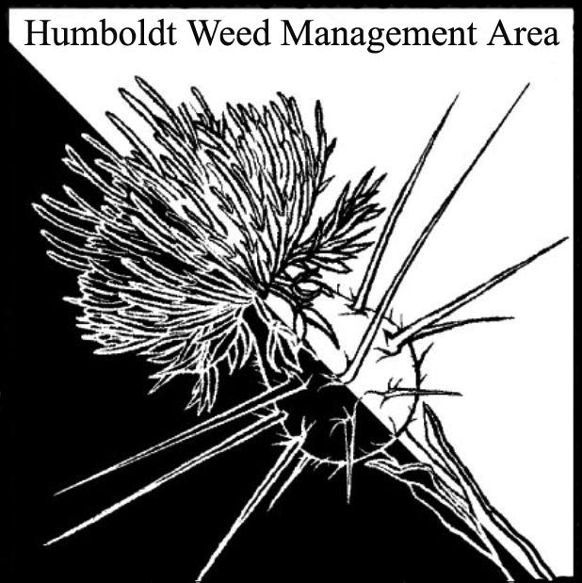

1. **Welcome Introductions/Sign-in**

Susannah Ferson (RCAA), Mike Van Hatten (USFWS), Andrea Pickart (HBNWR), Kelsey McDonald (USFWA), Gabe Cashman (GDRCo), Stephen Underwood (CNPS), Laurel Goldsmith (USFWS), Jessie Bunkley (Wildlands Conservancy), Crystal Welch (BLM), Patrick Hoffman (CAC)

1. **Special meeting to discuss herbicide use in Humboldt County (planning)**

Susannah Ferson receives frequent questions from various organizations and local leaders concerning both RCAA’s and other organization’s projects that involve herbicide use for control of invasives. Suggested we hold a special meeting to discuss herbicide use and invite specific interested parties. The benefits of a meeting in office versus at a field site were discussed.

Andrea Pickart suggested a planning committee be formed to explore the idea further. Susannah seconded. The committee members will include Susannah Ferson, Laurel Goldsmith, Crystal Welch, Kelsey McDonald, Stephen Underwood, and Patrick Hoffman.

1. **AB 99**

California Assembly Bill 99 was discussed, including its potential to limit Caltran’s options for control of invasive plants dependent on the policies of each county in which Caltrans operates.

1. **Round robin**

**Susannah Ferson (RCAA)** – Several on-going Spartina projects. Will begin Spartina removal on Tuluwat. Recently purchased a new Marsh Master.

**Gabe Cashman (GDRCo.)** – Gorse thrips release seems to have been unsuccessful. Will continue monitoring. Collaborating with Laurel Johnson (NPS) on yellow-star thistle removal in the Bald Hills through herbicide application. Spots near water/culverts are not treated. Manual removal of Scotch broom at Christmas Prairie.

**Stephen Underwood (CNPS)** – Annual CNPS wildflower show is coming up on May 5-7th. On-going ivy removal in Rohnert Park.

**Crystal Welch (BLM)** – Collaborating with the Trinidad Coastal Land Trust on Pampus Grass removal on steep terrain in Trinidad. Developing an interagency agreement with Bear River on invasive plant management. Updating informational kiosks with QR codes to facilitate collection of data on phenology of both native and invasive plants. Three acres of Ammophila were removed in 2022 through manual methods by MRC and CCC. Plans to use heavy equipment for Ammophila removal on the South Spit.

**Andrea Pickart (HBNWR)** – Planned work targeting ivy, cotoneaster, and other invasives was delayed due to multiple occurrences of rabid foxes. Hiring CCC crews to tackle these and other invasives. Two Spartina units will see treatment this year. Received $2 million to treat ammophila and yellow-bush lupin on the Wadulh Unit north of Lanphere.

**Kelsey McDonald (CDFW)** – Seeing positive results from herbicide treatments of ammophila on the Ocean Ranch unit.

**Patrick Hoffman (CAC)** – Continuing hand removal of shining geranium at two sites near Eureka. Knotweed biocontrol released at Eureka High School site and Fields Landing site do not appear to have survived over winter.

1. **Closing announcements**

a. Next meeting set for Tuesday, July 11, 2023

from 1 – 2:30 p.m. Location: Arcata BLM and online.