**HWMA Meeting**

Tuesday, April 9, 2024

Arcata BLM/Zoom Hybrid Meeting

1:00 – 2:30 p.m.

**Draft Minutes**

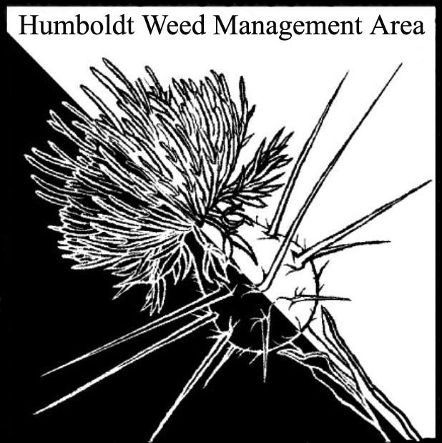

1. **Welcome – Introductions/January Minutes Approval**

Ron Sundberg (Trinidad Rancheria), Emily Afriate (The Wildlands Conservancy), Michelle Forys (CSP), Jane Dexter (MRC), Carl Klarner (RIPE), Steven Underwood (CNPS), Morguine Sefcik (City of Arcata), Patrick Hoffman (Humboldt CAC), Susannah Ferson (RCAA), Crystal Welch (BLM), Trevor Fox (CDFA), Hannah Atwood (City of Eureka), Stephen Underwood (CNPS), Tanya Chapple (MKWK), Gabe Cashman (GDRCo), Justyna Marszalek (Yurok Fisheries), Scott Estepa (BLM)

January minutes approved.

1. [**AB-2509**](https://gcc02.safelinks.protection.outlook.com/?url=https%3A%2F%2Fdxw8ysbab.cc.rs6.net%2Ftn.jsp%3Ff%3D001eM4j5wUa-JqhfNqf3p118EgocL6QnU0OGpXwQbdDZLRZ06ybsY0kT9nHRa5NEor5GJRDRkANCFPvWObXaK19tkjTYRV6GEDHhT_ma2Rb5GQL6kFDn_NTIuqyIE_vSJySs9CQzCDq0q0eF3mUKf_aEeyYpb6LyKsmWQ5GKXZjARKFkzMJCMMOIiY9n89QZKkBQ9t5UtPxdkYxdfMwbIWevoBOn0yc0ahO7qJH5u7SL1hs8ykTWqvWDg%3D%3D%26c%3DSZM5ju_LwGa0bXG0SidHStVpchI5pTqlDQygODbgHfvaF76imCnnvw%3D%3D%26ch%3DF50KAhXqQljejV8K7cD-tx9tZRfUhpSLtOXq25OUTIuvDvPsCAqJkg%3D%3D&data=05%7C02%7Cphoffman%40co.humboldt.ca.us%7C0f1398f0db5c42b01b8508dc4f53121d%7Cc00ae2b64fe844f198637b1adf4b27cb%7C0%7C0%7C638472465426973430%7CUnknown%7CTWFpbGZsb3d8eyJWIjoiMC4wLjAwMDAiLCJQIjoiV2luMzIiLCJBTiI6Ik1haWwiLCJXVCI6Mn0%3D%7C0%7C%7C%7C&sdata=mVG5nBcAcJQIk0%2BwA%2FT7yc2QTYlhJo3OBAc3H0M8mTI%3D&reserved=0) **– Defines Invasive Species and IPM**

This bill would define “Integrated Pest Management.” Patrick Hoffman said he would forward a Cal-IPC letter of support to members for review and sign-on if interested.

1. **MOU and bylaws review + Steering Committee Membership**

Updating the MOU and bylaws was discussed, including adding new member organizations and potentially removing non-participating organizations. Susannah and Patrick agreed to contact organizations that have not participated in recent years to confirm continued interest in remaining a signatory.

It was suggested that there should be a clearer description of the process for choosing projects to submit to CDFA for WMA grant funds.

Steering Committee membership was also discussed. This group consists of representatives of organizations that are currently and have historically been very active in the HWMA. It was suggested that the Steering Committee continue to consist of representatives of the organizations that have been the traditional members. This means the committee would consist of the following: Susannah Ferson (RCAA), Patrick Hoffman (Humboldt CAC), Stephen Underwood (CNPS), Crystal Welch (BLM), Tanya Chapple (MKWC), Michelle Forys (SP), John Hackett (Caltrans), Laurel Goldsmith (USFWS), and representatives from NPS, USFS, and CDFW. Representatives of NPS, USFS, and CDFW were not present, but historically have been very active.

1. **Round Robin**

Susannah Ferson (RCAA) – Contacted TCLT to see if they would be interested in working to encourage Trinidad property owners to control weeds. This was done in response to discussion Carl Klarner started at the April HWMA meeting concerning Trinidad area properties with large amounts of ivy. Have not heard back from TCLT yet. Spartina treatments continue at several sites, including Tuluwat. Working with Andrea Pickart on a large dune restoration project. Knotweed work continues. Invasives removal at the Humboldt Bay Power Plant. Conducting invasive plant inventory at the site of the Lightning and South Fork Fire Complexes.

Gabe Cashman (GDRCo) – Controlling star thistle in the Bald Hills via herbicide and hand removal. Restrictions on herbicide use near aquatic sites limited ability to control star thistle in the past. Moving towards herbicide use on priority species, even when near aquatic sites. The biocontrol agent gorse thrips was released on gorse populations in 2022 and 2023. No establishment detected. Provided Jubata grass to USDA researcher for greenhouse trials using a gall midge biocontrol.

Justyna Marszalek (Yurok Fisheries) – Working on river restoration projects across the north coast.

Morguine Sefcik (City of Arcata) – Planning to begin removal of sponge at Arcata Marsh. Tried flaming shining geranium, will check back to assess effectiveness.

Scott Estepa (BLM) – Working on Ammophila and capeweed removal on the south spit.

Crystal Welch (BLM) – Hiring MRC and CCC for manual removal of invasives on the south spit. Had a conversation with county Public Works about inspecting gravel for weeds before use on county roads. They are open to the idea.

Stephen Underwood (CNPS) – Continuing ivy removal efforts at Rohnert Park.

Emily Afriate (The Wildlands Conservancy) – Two stewards focused on invasives removal on property in Trinidad. Have been working on removing capeweed in the Eel River estuary for seven years. Working with RCAA and RCD on Spartina removal in the Eel River estuary.

Tanya Chapple (MKWC) – Controlling Italian thistle and oblong spurge. Will be floating the Klamath in the Orleans area to survey for Dalmatian Toadflax.

Jane Dexter (MRC) – Pulling tansy ragwort on the South Spit and tansy, Scotch and French broom on the Lost Coast/King Range. Assisting with Lanphere Dune surveys post herbicide treatment of Ammophila.

Trevor Fox (CDFA) – Trevor is the new noxious weed program coordinator for CDFA. Drafting a call for proposals that will be open to WMA member organizations to fund noxious weed projects. Up to $40,000 may be available for each WMA. It is expected that the call for proposals will be released, and contracts signed, before July 1st.

Hannah Atwood (City of Eureka) – MOU with the Volunteer Trails Stewards to remove ivy and crocosmia. Contracting with RCAA for Spartina removal along the Elk River.

Patrick Hoffman (Humboldt CAC) – In the process of hand-pulling shining geranium at two sites in county ROW. One site has significantly decreased after two years of removal, but reduction at the second site is minor. Will be revisiting biddy-biddy site in Arcata, which was tarped last summer.

Carl Klarner (RIPE) – Starting a new group called Redwood Invasive Plant Eradicators (RIPE). Focused on cutting ivy at the base of trees. Has begun working with Caltrans on ivy removal. Cleared a large amount of ivy near Eureka High. Spent 440 hours in 2023 removing invasives.

1. **Closing announcements**
   1. CNPS Wildflower show May 3rd – 5th
   2. Next HWMA meeting is set for Tuesday, July 9, 2024

from 1 – 2:30 p.m. Arcata BLM/Zoom Hybrid Meeting