HWMA Meeting
Monday, January 9, 2023
Zoom meeting
1:00 – 1:55 p.m.

Meeting Minutes

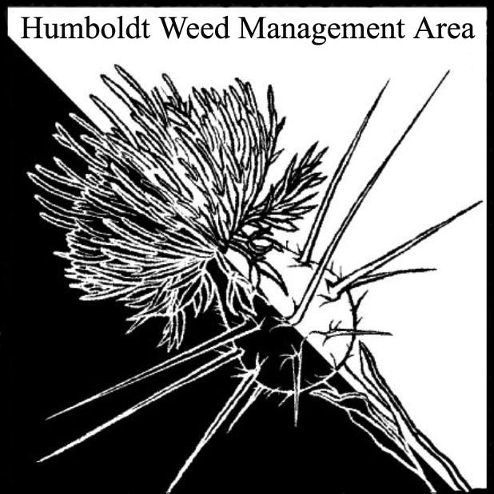

- Welcome - Introductions 1:00-1:05

Susannah Ferson (RCAA), Michelle Forys (SP), Hunter Mortensen (NRCS), Tanya Chapple (MKWC), Kelsey McDonald (CDFW), Kimberly Davis (Hoopa Valley Tribal Forestry), John Hacket (Cal trans), Crystal Welch (BLM), Patrick Hoffman (CAC)

- Round Robin 1:05-1:55

Susannah Ferson (RCAA) – Spartina removal projects are on-going. Waiting for Coastal Commission okay to treat Spartina on Tolowa Island. Will be working on Lupinus arboreus and Ammophila removal on the Bair, Male’l, Lanphere, and neighboring units.

John Hacket (Caltrans) – Working on permitting to chemically treat Geranium lucidum.

Michelle Forys (SP) – Vinca infestations in Humboldt Redwoods SP are nearly eradicated. Stinkwort on Dyerville Loop road saw year two of manual removal. Broom removal and controlled burning of prairies in Humboldt Redwoods expanded to include prairie near Albee Creek. Medusa-head is spreading in treated prairies. There are plans to treat chemically. Medusa-head responds to treatment using herbicide designed for broadleaf species, thereby allowing prairies to be treated without destroying native grasses. Other recent projects include ice plant removal at the Lagoons and Ammophila removal at Little River.

Kimberly Davis (HVTF) – Quoted from Zoom chat box: “We monitor our timber harvest units for IPS continuously and treat when we can. We do have a huge Cal Fire project that is removing underbrush and pepperwood trees along the western border of the reservation in an attempt to create a buffer zone to help protect our tan oak trees from SOD pathogen; also we do our annual SOD stream monitoring. No other IPS based projects currently, but hopefully I will be able to get some funding to start some soon.”

Kelsey McDonald (CDFW) – Working on the Ocean Ranch Restoration Project. CDFW recently acquired a new conservation area containing infestations of reed canary grass and Yellow-star thistle. Asked whether attending members have experience treating large areas of reed canary grass.

Tanya Chapple (MKWC) – Monitoring/working in recent burn areas. Is now a member on Cal-IPC’s board of directors.

Crystal Welch (BLM) – Controlling Ammophila on dunes with CCC crew. Working towards control using heavy equipment. Coordinating with Trinidad Rancheria on weed control efforts in Trinidad. Use of weed matt for three months on Arctotheca calendula at Centerville Beach significantly reduced the population there.

- Closing announcements 1:55-2:00
a. Next meeting set for Monday, April 10, 2023
from 1 – 2:00 p.m. Location: hybrid meeting at Arcata BLM office and online

