HWMA Meeting
Monday, October 10, 2022
Zoom meeting
1:00 – 2:00 p.m.

Minutes

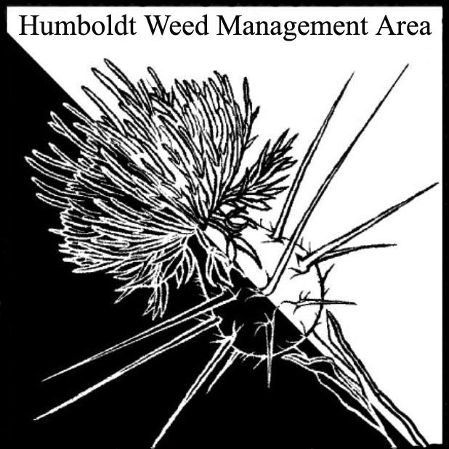

- Welcome - Introductions (1:00)
Susannah Ferson (RCAA), Patrick Hoffman (CAC), John Hackett (Caltrans), Stephen Underwood (CNPS), Laura Julian (NPS), Thomas Saunders (Trinidad Rancheria)

- $10 million in new funding for the WMA program in state budget (1:05)
Likely to come in the form of competitive grants in late 2023.

- 2022 Statewide WMA Meeting will be held online Nov. 1 from (1:10)
8:00-10:00 Cal-IPC asking each WMA to submit a brief (3 min)
pre-recorded update, due 10/21/22.

Susannah Ferson agreed to complete and submit the update.

- Cal-IPC symposium will be online again Nov. 1-3 (1:15)
The state-wide WMA meeting portion is free and will be held from 8:00-10:00 am on November 1st.

- Round Robin (1:20)

Patrick Hoffman (CAC) – Annual knotweed treatments complete. Number of sites continue to shrink. Two sites have been reserved for knotweed psyllid biocontrol releases by Chris Borkent with CDFA’s biocontrol program. Three attempts made so far with no establishment. Tansy ragwort removal on Woodley Island with RCAA. Other small Tansy sites around the Bay removed. Found star-thistle x spotted knapweed hybrid near Mad River near hatchery. Monitoring increasing spread of kangaroo apple (Solanum laciniatum) between Trinidad and Eureka.

Stephen Underwood (CNPS) – Working with group to conduct ivy removal in Rohnert Park.

John Hackett (Caltrans) – Monitoring site on 299 where wood chip mulch is being used to smother shiny geranium. Concerned about Arundo site near School Rd in Mckinleyville.

USFWS/HBNWR – New land holding recently obtained. Received $600,000 in grant funds to control invasives (including yellow bush lupin) and restore native dune mat. Removing Ammophila at Lanphere and Mal’el Dunes.

Thomas Saunders (Trinidad Rancheria) – Ivy removal. Single knotweed site being treated by RCAA. Looking into techniques for controlling bindweed. Increasing coordination with Trinidad Coastal Land Trust.

Laura Julian (NPS) – Completed seasonal control efforts for broom in the Bald Hills. Currently treating harding grass, shiny geranium, herb Robert, and ice plant. Unable to treat Ammophila at Freshwater Lagoon or Himalayan Blackberry this year. Expect to be able to next year.

Michelle Forys (SP) — Not present but provided round robin information to Patrick Hoffman before the meeting, which he presented. Treated almost all stinkwort in Humboldt Redwoods State Park. A lot of broom removal in Humboldt Redwoods State Park paired with prescribed burns. New spiderwort infestation found in Humboldt Redwoods State Park has received full initial treatment. Retreated beachgrass at Little River State Beach.

- Coordination with roads crews
A subcommittee was formed consisting of Susannah Ferson, Laura Julien, John
Hackett, and Patrick Hoffman. This group will reach out to Caltrans and the County
Roads Division to discuss the timing of roadside mowing and the possibility of
coordination.

- Closing announcements 1:55-2:00
a. Next meeting set for Monday, January 9, 2022
from 1 – 2:00 p.m. Location TBD

