HWMA
Steering Committee Meeting
Monday, April 11, 2022
Zoom
1:00 – 2:00 p.m.

Minutes

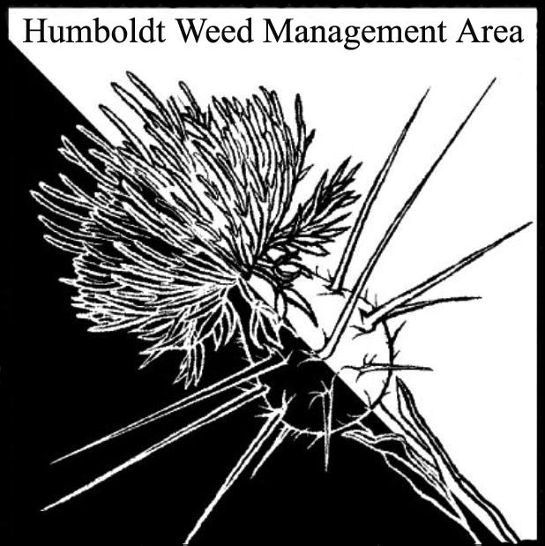

- Welcome
  - Introductions/Sign-in
Stephen Underwood (CNPS), Gabe Cashman (GDRCo), Ethan Donoghue (HRC), Katie Rian (CSP), Candace Reynolds (RCAA), Gregory O’Connell (CDFW), Jillian Zimmerman (USFWS), Crystal Welch (BLM), Kelsey McDonald (CDFW), Laurel Goldsmith (USFWS), Patrick Hoffman (CAC), Michelle Forys (CSP)
  - January minutes approved

- Shining geranium (Geranium lucidum) updates

- John Hackett (Caltrans) confirmed new site at mm 21 near Phillipsville on south bound HWY 101. This is the first site south of Eureka. An additional site was found in Arcata on Zehndner Ave via an iNat post and confirmed by Mike Weldon (CAC). It is likely more widespread. Patrick Hoffman asked if anyone would be interested in a field visit so that members can familiarize themselves with G. lucidum. A scheduling email will be sent out.

- Round Robin Stephen Underwood – CNPS plant show scheduled for April 29 – 30th and by appointment plant sale April 30 – 1st.
Patrick Hoffman – CAC’s office has been hand-pulling shining geranium at Eureka sites. Working on plans for release of biocontrol agent knotweed psyllid in conjunction with CDFA next month. Will be manually removing tansy ragwort on Woodley Island this summer with assistance from RCAA.
Gabe Cashman – Planned herbicide treatments and hand removal of star thistle near the Bald Hills. Working towards eradication in that region. There is potential for Calfire planned burns in the area, so it is especially important to reduce invasive plant source populations in the area to avoid colonization of newly burned sites. Will be revisiting sites of last year’s gorse thrips introduction to determine whether efforts were successful.
Jillian Zimmerman – Working on annual grass and yellow bush lupin removal on the dunes with CCC. Recently held the annual Lupin Bash volunteer workday.

Kelsey McDonald – Developing plans for invasive monitoring and treatment as part of the Ocean Ranch project. Will begin hand pulling of Arctotheca calendula soon.
Crystal Welch – Several project proposals are in the works. Hoping to do Ammophila removal using heavy equipment. Tried covering A. calendula with weed mat, which successfully killed the calendula and all other plants covered. Asked members if anyone has experience controlling velvet grass.
Laurel Goldsmith – Hand-pulling of A. calendula is on-going. Monitoring dunes for Star mustard.
Gregory O’Connell – Working on CEQA review for upcoming projects. Concerned about reed canary grass at a fen near McClellan Mt. and at the Orick Mill Site where restoration work is underway. Planning to map Pampus grass in Arcata with removal in mind. Asked group if anyone has experience using a mini excavator for pampus removal.
Michelle Forys – Received 4.5 fiscal years of funding to allow hiring of four additional staff. Will be conducting broom removal work, floodplain restoration, and expanding controlled burns. Beach grass, spiderwort, and Italian arum have seen recent control efforts. Spiderwort is under good control. New Italian arum sites were recently located. Applying for a grant to remove Ammophila at Little River with heavy equipment. Has had success controlling reed canary grass by tarping on flat ground. This method does not work on sloped sites. EDRR work beginning. Will be watching stinkwort population on Dyerville Loop Rd and will reach out to WMA members to schedule a group site visit when weed is actively growing.
Candace Reynolds – Spartina work in the Eel River and Elk River estuaries and on Tuluwat will begin soon. Removal of other invasives in the Elk River estuary has already been underway.

- Closing announcements (1:45)

  - Upcoming Cal-IPC free trainings:
    - Setting up EDRR Email Alerts in Calflora Wednesday, April 13, 11-12:00 Register at: https://us02web.zoom.us/meeting/register/tZAsf-muqzguGNRWocPdldARFJq-sxwF6cjQ
    - Tracking Management in Calflora Wednesday, April 20, 11-12:00 Register at: https://us02web.zoom.us/meeting/register/tZElcOitrDosH9Di2lxmXv15_YjXxdpmaRfb
  - Next meeting set for Monday, July 11, 2022 from 1–2:30 p.m. Consensus was to keep meetings remote (invite will be sent via email)

