HWMA
Steering Committee Meeting
Tuesday, January 11, 2022
Zoom
1:00 – 2:00 p.m.

Minutes

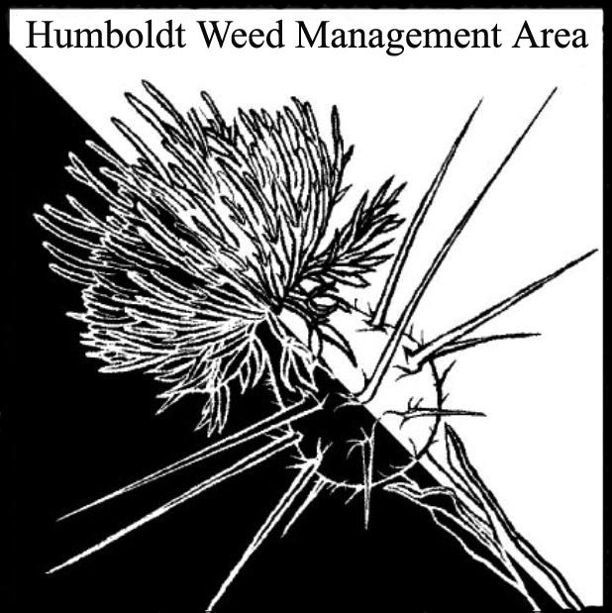

- Welcome – Introductions/Sign-in
Laura Julian (NPS), Stephen Underwood (CNPS), Candace Reynolds (RCAA), Michelle Forys (CSP), Katrina Henderson(CSP), Brooke Roehrick (CSP), Ethan Donoghue (HRC), Crystal Welch (BLM), John Hackett (Caltrans), Patrick Hoffman (CAC), Crystal Welch (BLM), Tanya Chapple (MKWC)

- Stinkwort (Dittrichia graveolens) detections
Discussion surrounding the first confirmed detection of Stinkwort in Humboldt County during summer of 2021. The infested site covers several acres along Dyerville Loop road and includes property owned by NRCA, State Parks, HRC, and Humboldt County. Katrina Henderson reached out to NRCA but has not received a response. John Hacket has since found several sites along 101 between mile markers 6.6 and 41. Michelle Forys will plan to invite WMA members to visit the Dyerville site during State Park’s next treatment effort to familiarize themselves with the plant.

- Round robin
- Stephen Underwood: CNPS sent letters in support of two recent prescribed fire bills, which were subsequently passed by the California legislature.
- Candace Reynolds: Several projects are in the planning phase, including a 115-acre invasive Spartina removal project at the Eel River Estuary Reserve, Spartina removal on Tuluwat Island, and removal of Spartina and other invasives in the Elk River estuary along with tidal marsh restoration.
- Patrick Hoffman: Completed fall knotweed treatments in County ROW. CAC’s office will hand pull two Geranium lucidum sites in County ROW near Eureka this spring. These sites were previously hand pulled annually by RCAA, but their funding for those efforts has expired. Tansy flea beetle’s were distributed to eight local ranchers for release on Tansy ragwort populations on their land.
- Michelle Forys: Gearing up for Ammophila removal in multiple locations, restoration work at Tolowa Dunes SP, completed Tradescantia treatments at Humboldt Redwoods SP and John B. Dewitt Redwoods Reserve, continuing Arum italicum treatments, adding oyster shell to beaches to increase cryticness of Snowy Plover nests, etc. More than 65 projects underway or upcoming.
- Crystal Welch: Hand pulling of Arctotheca calendula has occurred at Centerville Beach for many years. Will try tarping this year. Lots of funding is available for Ammophila removal. Requested ideas for non-chemical treatment of Ammophila beyond hand removal.
- John Hackett: Efforts to remove Pampas grass along the 101 safety corridor are ongoing. Pampas grass removal along the Arcata bike path in this location is completed. Will try using wood mulch to smother Geranium lucidum sites in Caltrans ROW this year.
- Laura Julian: There are plans to treat 24 species this year. Has switched to chemically treating Geranium robertianum after years of manual removal efforts that had minimal success. Chemical treatments are showing positive results. Geranium lucidum and Ammophila are also being successfully treated with herbicide. Concerned about an on-going Allium triquetrum invasion at Freshwater Lagoon.
- Tanya Chapple: New volunteer day calendar will be out soon. Continuing weed work in conjunction with fire related work, including areas burned as part of the McCash fire.

- Closing announcements
a. The next meeting was set for Monday, April 11, 2022
from 1 – 2:30 p.m. Location TBD

