HWMA
Steering Committee Meeting
Tuesday, July 19, 2021
1:00 – 2:00 p.m.

Meeting Minutes

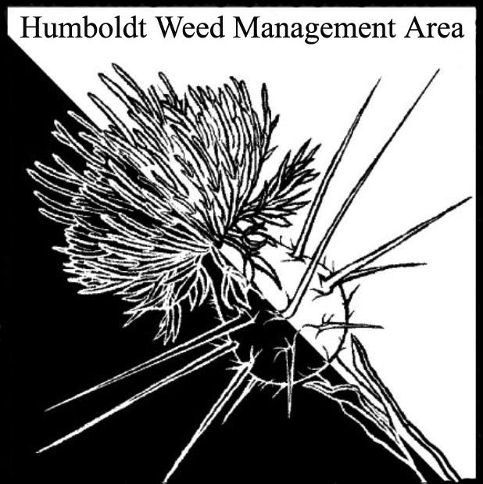

- Welcome – Introductions (meeting participants):
Susannah Ferson (RCAA), Michelle Forys (CA State Parks), Crystal Welch (BLM), Lisa Hintz, Gabe Cashman (GDRCo), Laurel Goldsmith, Greg O’Connell, John Hackett (Caltrans), Patrick Hoffman (Humboldt Co. Ag.)

- County Fair table
Patrick Hoffman volunteered to pay the HWMA registration fee and set-up the informational fair table. He requested help with sample collection and table set-up. Crystal Welch and Laurel Goldsmith suggested a Google doc sign-up list be created and sent to the HWMA email list to solicit volunteers.

- Round Robin
  - Susannah Ferson: Requested knotweed treatment data from organizations participating in the WCB funded knotweed eradication project. This is the last year of project funding. RCAA is conducting invasive monitoring work at the site of last year’s August Complex Fire, continuing Spartina treatments with new sites added, treating invasives on Trinidad Rancheria property, and working with the Fortuna Fire Department on an invasives mitigation project.
  - Crystal Welch: Received a promotion to Ecologist, filling the vacancy left when Jennifer Wheeler changed positions at the BLM last year. Crystal is working on an ESR plan for the August Complex. Currently taking an inventory of plants present. Lots of yellow-star thistle. MRC and CCC continuing work in the King Range and on the dunes.
  - Gabe Cashman: Treating yellow-star thistle in the Bald Hills. Working with USDA to introduce gorse thrips as a biocontrol on small patches of gorse at sites where herbicide applications are not made.
  - Michelle Forys Transplanted 2,400 violet plants to Tolowa Dunes SP to support Oregon silverspot butterfly habitat restoration. Recently finished annual cutting of purple loosestrife inflorescences. Treating invasives in Grasshopper Prairie at Humboldt Redwoods SP and hand removal near Albee Creek. New spiderwort, stinkwort, and carpet bugle infestations at Humboldt Redwoods SP. SCA is working on weeds in Sinkyone Wilderness SP. State parks has received funding for a year-round crew targeting fire, fuels, forest resilience. Multiple iNat projects are planned.
  - Laurel Goldsmith: Working on the Ocean Ranch project. Treating Ammophila and Spartina.
  - Greg O’Connell: Will be working on the Ocean Ranch project in the future. Is concerned about reed canary grass. Although it is commonly considered native it exhibits many invasive qualities. State parks treats it as an invasive. There may be a cultivated variety with invasive tendencies that is present in wildlands. Will be keeping an eye on a restoration project at Wrigley Orchard along the Elk River. Reed canary grass is not present currently. Greg will be watching to see if it appears after dredging.
  - John Hackett: Targeting ladder fuels as part of a fuels reduction project.
  - Patrick Hoffman: Surveying lower Mad River for spotted knapweed. Working with CDFA to introduce Japanese knotweed psyllid as a biocontrol agent for Giant and Japanese knotweed. Will be treating knotweed on county property in September.

- Closing announcements
a. Next meeting set for Tuesday, October 12, 2021
from 1 – 3 p.m.

