HWMA
Steering Committee Meeting
Monday, January 13, 2020
BLM Conference Room
1:00 – 3:00 p.m.

Meeting Minutes

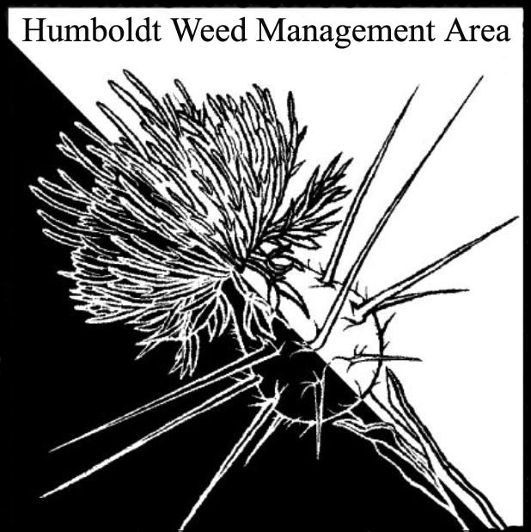

- Welcome
  - Introductions (meeting participants): Susannah Manning (RCAA), Katrina Henderson (CSP), Stephen Underwood (CNPS), Domenic Bongio (CalTrans), Crystal Welch (BLM), Jennifer Wheeler (BLM), Patrick Hoffman (HumCo Ag), John Summers (MRC), Tanya Chapple (MKWC), Michelle Forys (CSP), Lisa Hoover (USFS)

  - Approval of October minutes: Minutes from the last meeting were not distributed prior to today’s meeting. Patrick Hoffman will email minutes to participants for approval.

- Revisit priority species list
Jennifer Wheeler brought up the importance of the local priority species weed list in facilitating interagency cooperation and prioritization of projects. The current knotweed eradication effort is an example of this. The ratings for several of the listed species were reviewed and confirmed or changed. It was agreed that an email solicitation should be sent to the larger HWMA group requesting recommendations about updates to the current list. Feedback from the larger group will be used to inform the continued review of priority ratings at the next meeting.

- North Coast Regional Plan discussion/DNWMA
Discussion from the October meeting was reviewed. DNWMA members are interested in partnering with HWMA on grants. Dana Morawitz of Cal-IPC proposed that occasional regional meetings be held combining HWMA and DNWMA. Michelle Forys suggested that it is best if both groups apply for grants separately, but that synergistic plans would be beneficial. Michelle will contact DNWMA about meeting.

- Open
Tree-of-Heaven (Ailanthus altissima) Control/Eradication
The feasibility of eradicating Tree-of-Heaven was discussed. An inventory of this species in Humboldt County is needed.

Pesticide Use by Caltrans
Caltran’s policy regarding herbicide use was discussed. Since the mid-90’s Caltrans has honored a Humboldt County Board of Supervisor’s request that chemical control of vegetation within unincorporated areas of Humboldt County be avoided. More recently Caltrans has said that they may make some small chemical applications for purposes of traffic safety or for the safety of workers.

CDFA Grant Proposal Preparation
Susannah Manning and Jennifer Wheeler suggested that HWMA members work on project proposals to be discussed at a future meeting so that the group is ready when grant funds are made available by CDFA.

- Round robin
Domenic Bongio: Working on PG&E requests for tree removal. Domenic’s last day with Caltrans will be October 31, 2020.
Tanya Chapple: Continuing work on pairing invasive plant management with fire management. Working on Himalayan Blackberry control.
Lisa Hoover: Also working on integration of invasive plant and fuels management. Diffuse Knapweed management efforts will be continued this summer.
Stephen Underwood: Is the new California Native Plant Society representative in the HWMA group.
Patrick Hoffman: Replacing Bryan Atkinson as the HWMA Co-chair and HumCo Ag Dept representative. Bryan has accepted a position with Caltrans. HumCo Ag treated several knotweed sites in fall. Sites will be revisited in spring.
Michelle Forys: Burning Grasshopper Meadow. Will also be conducting herbicide applications for thistle control. Organizing CCC removal of Arundo on the South Fork Eel River.
Katrina Henderson: Will have 15 interns from HSU and CR to assist weed management efforts this season.
John Summers: Is leaving MRC. MRC has been approved for $50,000 in funds to continue weed treatments in the King Range.
Crystal Welch: Managing invasive plant removal in Male’l and CCC crew work on the South Spit.
Susannah Manning: RCAA is continuing Spartina and Arundo treatments and has been contracted to do invasive plant management in the area of the Sims fire.

- Closing announcements
a. Next meeting set for Monday, April 13, 2020
from 1 – 3 p.m. at the Arcata BLM Field Office.
EDIT: Do to the on-going Covid-19 pandemic the April 13, 2020 HWMA meeting will be a conference call.

