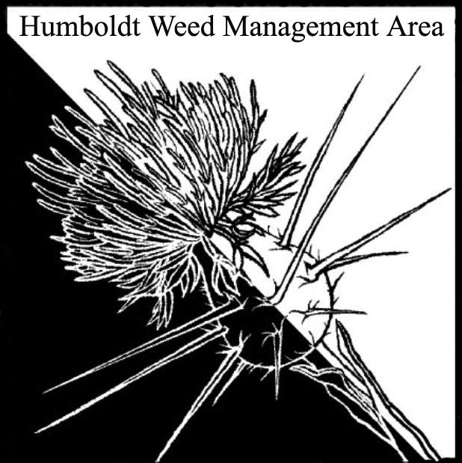
HWMA
Steering Committee Meeting
Monday, October 15, 2018
BLM Conference Room
1:00 – 3:00 PM

Meeting Minutes

- Welcome: Amy Eberwein, Co-Chair

Introductions (meeting participants):
Amy Eberwein (RCAA, FOD), Michelle Forys (CA State Parks), Susannah Manning (RCAA), Domenic Bongio (Caltrans), Jennifer Wheeler (BLM), Karlee Jewel (NCRLT)

Approval of Minutes:
Minutes from the last meeting on July 11, 2018 were approved.

- Invasive Weeds of Humboldt County 3rd Edition:
HWMA members worked together to read through and edit the introduction text for the 3rd edition. Time was also spent reviewing photos and line drawings. Concerns with three-cornered leek (Allium triquetrum) led to adding this species to the 3rd edition. In order to make it fit into the formatting of the booklet Acacia species will be combined. Herb Robert (Geranium robertianum) will also be added in with shiny geranium to allow for the addition of this rapidly spreading species.

- Round Robin (informal member reports): Cut short due to time constraint
  - Domenic Bongio: Found knapweed on RNP bypass. Arundo found on Hwy 299 is Caltrans ROW. Couple of knotweed sites were no detect this treatment season.

  - Amy Eberwein: Working on handing over WCB project and HWMA duties to Susannah Manning (Project Coordinator). Friends of the Dunes is facing issues with CDP and Planning Commission due to misinformation from vocal minority. Support is needed.

III. Next HWMA meeting
Next meeting set for Monday, January 14th, 2019 from 1 – 3 p.m. at the Arcata BLM field office.

