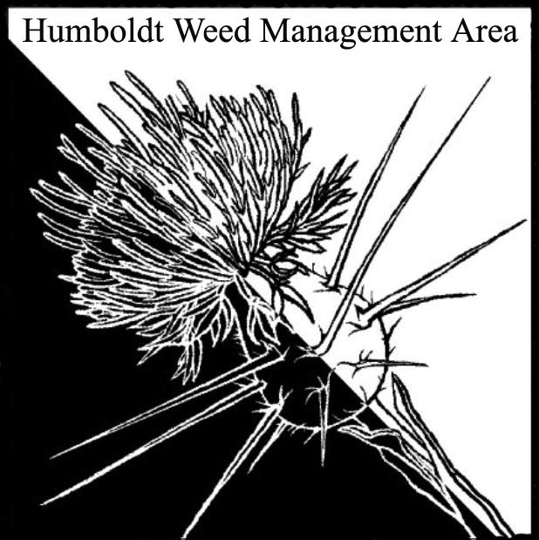
HWMA
Steering Committee Meeting
Wednesday, July 11, 2018
BLM Conference Room
1:00 – 3:00 PM

Meeting Minutes

- Welcome: Bryan Atkinson and Amy Eberwein, Co-Chairs

Introductions (meeting participants): Bryan Atkinson (Humboldt Co. Ag), Amy Eberwein (NRS-RCAA), Ashley Disney (CA State Parks), Pete Luvaas (CCC), Susannah Manning (NRS-RCAA), Greg O’Connell (CDFW), Domenic Bongio (Caltrans), Laurel Goldsmith (USFWS), Bianca Hayashi (CDFW), Mike van Hattem (CDFW), Andrea Pickart (USFWS), Doyle Doss (Waterfront Trail).

Approval of Minutes: Minutes from the last meeting on April 16, 2018 were approved.

Humboldt County Fair Booth Prep: Bryan Atkinson will be leading the effort to prepare the booth for this year’s fair. Email to follow.

- Special Guest Dana Morawitz (Cal-IPC): Dana presented Cal-IPC updates, and an overview of uses of the Calflora/CalWeedMapper databases.

- Round Robin (informal member reports)
  - Doyle Doss: Plant ID questions (Rumex, Clarkia). Techniques for pampas removal on the Hikshari trail.
  - Domenic Bongio: Pulling broom with CCC’s. New shining geranium sites and issues with treatment (doesn’t seem to be eradicable at this point). Found Lanceleaf nightshade north of CR.
  - Greg O’Connell: Discussed potential for including invasive plant management in permit conditions for cannabis grows. Eucalyptus tree removal along Hwy 101 for Humboldt Bay Trail – supporters of removal are encouraged to attend and voice their support at the next supervisors meeting (contact Greg for more info).
  - Laurel Goldsmith: Discussed fertile variety of capeweed in Ferndale and Eel river and estuary eradication efforts.
  - Bianca Hayashi: Making headway in recommendations for protection measures for rare natural communities in timber plans, including invasive plant management.
  - Bryan Atkinson: Working on spotted knapweed near Blue Lake. Keeping an eye out for thistle populations in Honeydew.
  - Ashley Disney: Michelle is working on Purple Loosestrife on the Eel River. Retreated European Beach Grass from Fern Canyon to Ossagon.
  - Pete Luvaas: Working with BLM at the south spit on European Beach Grass removal. Caltrans mitigation work. Will also be working on Spartina removal with RCAA.
  - Mike van Hattem: Notice of preparation of EIR for the Eel River Wildlife Area (levee removal and European Beach Grass removal) is now available for public comment. Working on peatland invasive plant issues including reed canary grass and teasel. Acquisition of Hambro parcel in Crescent City (137 acres of wetland/sitka spruce stand with ivy infestation).
  - Amy Eberwein: Del Norte County is hiring a new Ag Commissioner. Friends of the Dunes is desperately seeking board and committee members. Attended CISAW event and passed out many weed booklets. Presenting at the Cal-IPC symposium this year on the knotweeds project. New knotweed sites on County property, reduced numbers at all other sites. Sent in a letter to Eureka Costco asking them not to sell Crocosmia spp.
  - Susannah Manning: Marsh master is up and running at the G Street marsh in Arcata. Treating for Prop 1 grant and then moving down into the Harbor District areas and South Bay.
  - Andrea Pickart: Working on annual grass treatments, restoration on the Bair parcel using soil inversion technique on yellow bush lupine. Youth Conservation Crew is working on removal of ice plant. Work on Spartina at the Eureka slough unit. Ammophila breviligulata at King Salmon – Harbor District wants to work on eradication.

III. Next HWMA meeting
Next meeting set for Monday, October 8th, 2018 from 1 – 3 p.m. at the Arcata BLM field office.

