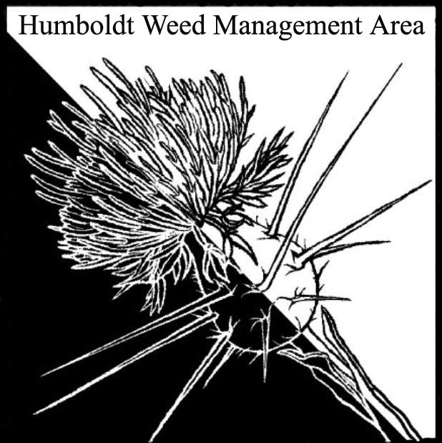
HWMA
Steering Committee Meeting
Monday, January 14, 2019
RCAA Conference Room
1:00 – 3:00 PM

Meeting Minutes

- Welcome: Susannah Manning, Co-Chair

Introductions (meeting participants):
Susannah Manning (RCAA), Michelle Forys (CA State Parks), Domenic Bongio (Caltrans), Bryan Atkinson (Humboldt Co. Ag).

Approval of Minutes:
Minutes from the last meeting on October 15, 2018 were not available, minutes will be sent to attendees for approval.

- Invasive Weeds of Humboldt County 3rd Edition:
HWMA members worked together to read through and edit the text for the 3rd edition. Topics covered are listed below:
- Corrections to font sizes were made.
- Capitalize all common names, a.k.a. names were not capitalized previously.
- Nomenclature to follow Jepson interchange as indicated on back cover.
- Edits will be made and revised copy will be sent out to group.

- Round Robin (informal member reports):

  - Domenic Bongio: Shiny Geranium is growing, flowering and going to seed. Missed the window for a fall treatment. Area treated has now grown to 9 acres, mostly in Del Norte. Desires to treat twice per year. Has concern with geranium spreading in Klamath. Is now prepping for spring treatments. Treated two spots of Arundo on HWY 299 in October between Willow Creek and Salyer.
  - Michelle Forys: Keeping after Ivy. Has been retreating the normal stuff. Parks are in review for treatment of Shiny G.
  - Susannah Manning: Compiling data from past years and working on prepping for this year’s treatments. Working to extend WCB grant, will be doing some site visits with WCB. Spartina treatments are ongoing; Dead Mouse marsh is a new site being treated. Working to secure funding for continued Spartina removal.
  - Bryan Atkinson: Monitoring spotted knapweed near Blue Lake. Not much activity at this time of year.

III. Next HWMA meeting
Next meeting set for Monday, April 15th, 2019 from 1 – 3 p.m. at the Arcata BLM field office.

