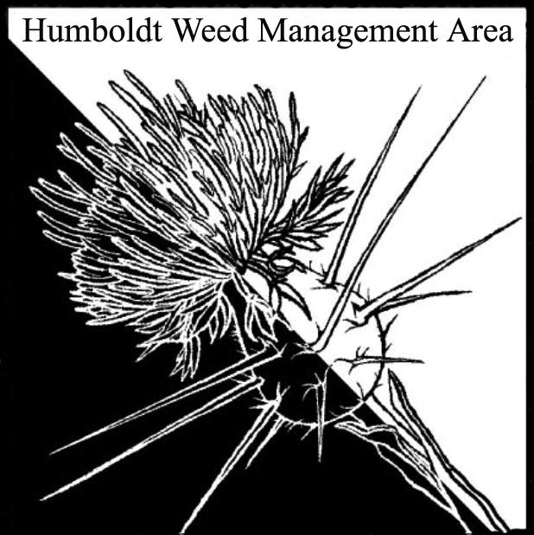
HWMA
Special Meeting
Wednesday, March 13, 2019
BLM Conference Room
3:00 – 5:20 PM

Meeting Minutes

- Welcome: Susannah Manning, Co-Chair

Introductions (meeting participants):
John Summers (MRC), Judy Haggard (MLT), Ben Morehead (TCLT), Susannah Manning (RCAA, FOD), Domenic Bongio (Caltrans), Jennifer Wheeler (BLM), Bryan Atkinson (Hum Co. Ag.), Doreen Hansen (HCRD), Steve Madrone (5th District Supervisor), Lisa Hoover (USFS).

- Review and Discussion of Grant Eligibility and Exclusion:
Attending members reviewed the request for proposal (RFP) for requirements and desires. Collaboration among organizations through WMAs was identified as a priority.

- Round Robin (informal project proposals): Brief outline of proposals were presented for selection by the attendees.
  - USFWS, Andrea Pickart (presented by Susannah Manning): Spartina removal on USFWS Eureka Slough Unit. Possibly outlier Spartina, fits into regional Spartina plan.
  - Arcata, Julie Neander (presented by Susannah Manning): Invasive species removal project. Reed Canary, Pampas grass, Ivy, Spartina, Parrot Feather, Frog-bit, Brooms, No use of pesticides.
  - RCAA, Susannah Manning: Continuation of Knotweed project, is in last year and is applying for an extension, new populations have been discovered. Current funding requirements not acceptable by many landowners so a number of populations are not being treated.
  - McKinleyville Land Trust, Judy Haggard: Needs help with Ivies and Brooms, does not have a proposal ready and would like to possibly partner with another project.
  - Humboldt RCD, Doreen Hansen: Project targeting Spartina in the Salt River Restoration Area, lower Eel River. Low density areas 8-10 acres previously mapped. Recently restored area being invaded with Spartina. Rebuilding wetlands and native species, adjacent to agriculture with Spartina encroaching.
  - USFS/Hayfork Watershed Center, Lisa Hoover: Knapweeds in Humboldt County, mostly mapped, Spotted and Diffuse Knapweeds. 22 sites near Pilot Creek watershed. Pilot Creek not infected. Many sites have been treated. NEPA done, might need more mapping. Discreet sites on road edges. Includes areas of Oak Woodlands.
  - Trinidad Coastal Land Trust (TCLT), Ben Morehead: South Scenic Dr. invasive removal project. Work with Cal-Trans right of way and state parks to remove invasive species from Westhaven Drive overpass south to Little River Estuary. Set up some test plots for trials of removal options. Species are English & Cape Ivy, Pampas grass and Brooms. Concerned with roadside safety and protection of sensitive habitat (Pilot Point).
  - MRC, John Sommers: 3 parted project. 1) Mattole River riparian assessment, float the Mattole to assess invasive population on mid-channel islands and banks. Not done before. 3 threatened salmonids in Mattole. 2) Perform English Ivy removal, 6 populations, landowner approval obtained, to protect public lands (BLM). 3) Malta Star thistle (Centaurea melitensis) removal, 2 populations, private land in Honeydew.
  - Mid-Klamath Watershed Council, Lisa Hoover: Project in Humboldt County, requested $21,600. Multiple species – riparian Oblong and Leafy spurge, small populations of knapweeds, brooms near wilderness, Dalmatian Toadflax, Perennial Pepperweed, All A-rated/red alert weeds. Partnered with Karuk Tribe, Six Rivers National Forest and private landholders.
  - Steve Madrone (Humboldt County): Spoke about projects not meeting CEQA if they have not addressed follow up treatments on a project and potential for invasive overtake. Gave examples of Broom and Pampas grass removal and use of waste as a solution for other issues; such as Hammond trail Pampas grass and broom removal and use of plant material as fill.
Past removal of Pampas grass and brooms from the 101 corridor between Eureka and Trinidad. Now maintenance is not there and the weeds are coming back. Wants to think about vectors of invasive plants. Recommended to use a matrix for selection of projects to put forward.
Proposal, Steve later pulled from discussion: Pilot project to implement new strategy for roadside vegetation maintenance. P.E.R.M. Select a section of road and implement experimental treatments that allow for native plants to grow while minimizing spread of invasive plants. Examples given were hand pulling vs. mowing, moving plants to locations where they are desired (remove native plants from ditches and replant them for slope stabilization), cleaning equipment between treatments to prevent spread of invasive by machinery. This project is under discussion and sources of funding will be secured outside of this grant opportunity.

- Discuss Proposals and Assign Priority:
The group discussed each projects likelihood of being funded based on criteria set forth by CDFA, found in the eligibility and exclusions section of the RFP. Projects were then ranked based on the strategic point hit by each proposal.

- Populations identified in a regional strategic plan
- Populations of regionally rare weeds
- Outlier populations targeted for regional containment
- Populations threatening high value assets

- Select 3 Project Proposals for Submittal:
  - Hayfork Watershed Center and MKWC projects combined.
  - RCAA and MRC projects combined.
  - Humboldt RCD project.

