ERADICATION WORKPLAN for NORTHWEST – 2013
Regional stakeholders determined that the species listed below are eradicable from the Northwest region (Humboldt and Del Norte counties) within five years. This document describes the proposed management and cost necessary for eradication of these species. Send questions to mapping@cal-ipc.org or call 510-843-3902.

 | SPECIES |  | COMMON NAME | LINK TO MAP
 | 1 | Fallopia japonica (= Polygonum cuspidatum) | Japanese knotweed | CalWeedMapper: Fallopia japonica (= Polygonum cuspidatum)
 | 2 | Fallopia sachalinensis (= Polygonum sachalinense) | Sakhalin knotweed | CalWeedMapper: Fallopia sachalinensis (= Polygonum sachalinense)
 | 3 | Periscaria wallichii (= Polygonum polystachyum) | Himalayan knotweed | Calflora: Persicaria wallichii (= Polygonum polystachyum)
 | 4 | Arundo donax | giant reed | CalWeedMapper: Arundo donax
 | 5 | Lythrum salicaria | purple loosestrife | CalWeedMapper: Lythrum salicaria
 | 6 | Tamarix ramosissima | saltcedar, tamarisk | CalWeedMapper: Tamarix ramosissima
 | 7 | Euphorbia virgata (= Euphorbia esula) | leafy spurge | CalWeedMapper: Euphorbia virgata (= Euphorbia esula)
 | 8 | Chondrilla juncea | rush skeletonweed | CalWeedMapper: Chondrilla juncea
 | 9? | Euphorbia oblongata | oblong spurge | CalWeedMapper: Euphorbia oblongata
 | 10??? |  | shiny geranium | Calflora: Geranium lucidum
  Geranium lucidum (a new addition?) | shiny geranium
I. PRIORITY targets. Each species is described by total number of sites, treatment type, total acreage (or total number of plants if small), cost per acre to treat, total cost per year, # of years to eradicate:, and # of years to monitor. The intent is to have these species generally mapped by quad in CalWeedMapper and to have each occurrence mapped in Calflora (as a point, line or polygon). If detected in new areas, the species should be mapped and targeted for eradication. Regional partners will mobilize to respond rapidly and remove it.
Ii. Regional AREAS OF CONSERVATION EMPHASIS: These represent areas of high “biological richness” within the region, defined by biodiversity, rarity, irreplaceability and presence of sensitive habitats. 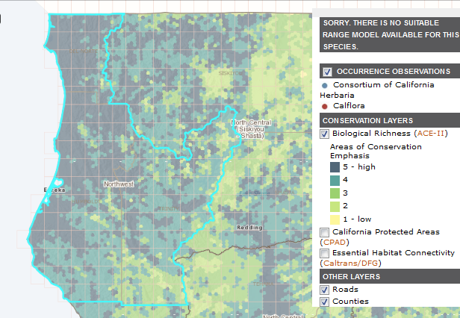

Targets 1-3: Fallopia japonica (= Polygonum cuspidatum) (Japanese knotweed)
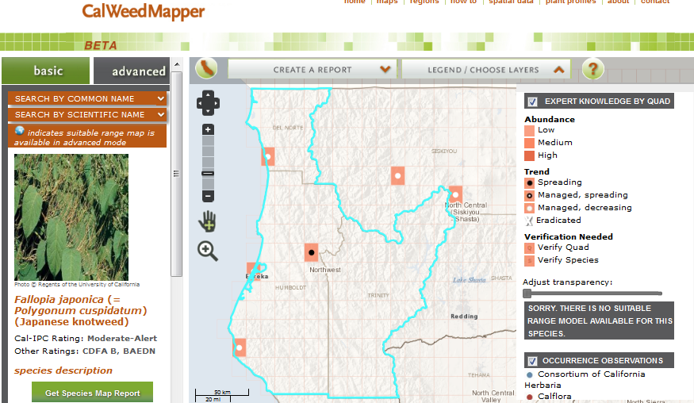
Fallopia sachalinensis (= Polygonum sachalinense) (Giant knotweed, Sakhalin knotweed)
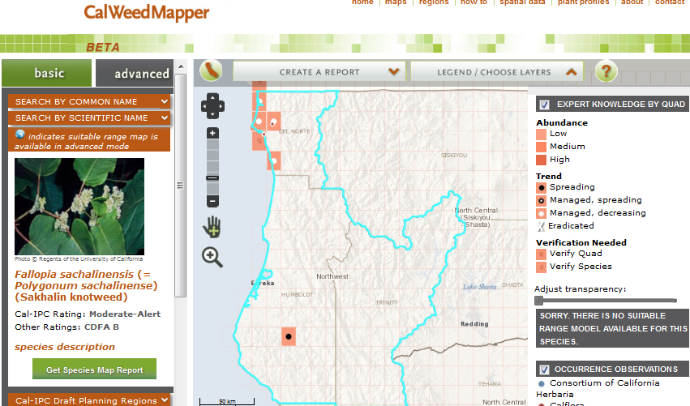
Periscaria wallichii (= Polygonum polystachyum) (Himalayan knotweed)
Contacts per species in Humboldt: Unity for Japanese knotweed, Domenic for Giant knotweed, & Michelle F. for Himalayan knotweed. Total effort in Humboldt would be $ 113,712 (see 20130123_NW Known Knotweed locations updated January 2013.xls compiled by Jennifer Wheeler.)
Contacts per species in Del Norte: Jim Buckles & Richard Nelson. Notes: We work with Redwood Natl/State parks and Cal-Trans, and 10k (2k/year) should be enough to eradicate in those areas of Del Norte County. The Yurok tribe part of Del Norte County (Richard Nelson - Richard@yurok.com, 707 482-0439), as they only allow chemical injection of the knotweeds. They would need an additional $5k for 3-4 years. Additional $5k needed for additional surveillance. Giant knotweed in a creek that feeds into the Klamath with endangered Coho. Total effort in Del Norte would be $35k.

Target 4: Arundo donax (giant reed)
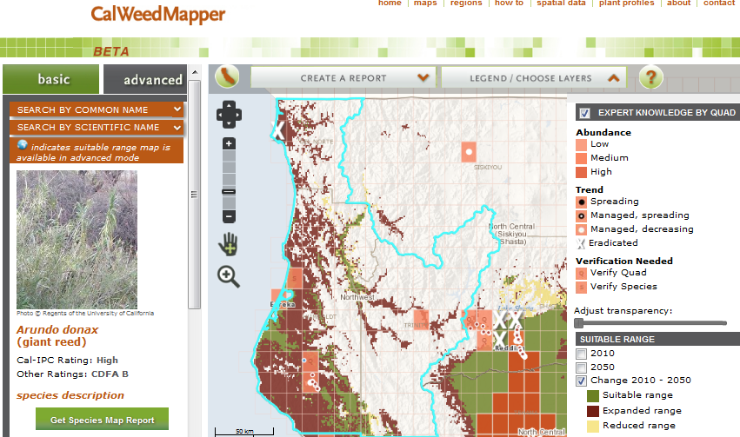
Giant Reed (Arundo donax) Eradication
Prepared by Andrea Poteet , Fish Habitat Specialist, andrea.poteet@ccc.ca.gov, 707-725-5106 (o) & 707-407-9306 (c)
To resolve: does this include all populations of Arundo that Andrea knows about and does it include Michelle’s coastal occurrences?
2012 costs:
Total number of sites: 7 treated
Treatment type: tarped, foliar spray, cut stump
Total acreage: 0.09 acres (4036ft2)
Cost to initially treat: 15,600. (treatment incomplete must retarp some areas)
Total cost per year: Year 1 - $15,600; Year 2 - $15,600; Year 3 - $ 15,600; Year 4 to 5 (spot treat/monitor ) - $15600($7800/yr); Year 6 to 10 (monitor) - $39000 ($7800/yr) .
Number of years to eradicate: 5 years
Number of years to monitor: 5 years
Total cost to treat $ 62600? ( 5 years), Total cost to monitor, $39000? ( 5 years)

Notes:
I have a hard time estimating # of years to eradicate. I continue to find new sites along the Eel River and have not treated some of the known sites (landowner access issues) for our treated sites I say three to 5 years to eradicate with continued monitoring. I have funding for the next two years to treat infestations from Benbow on the East Branch of the South Fork Eel River to the mouth of the Eel River where I found a clump on the beach. There is a small untreated clump on an island near the mouth that must be accessed by boat. My next big task is to have my crews walk the river bars along the forest edge where the Arundo lands. That will be about 1100 person hours to seek unfound Arundo.
Pre2012 Costs:
Total number of sites: These sites are all treated and the treatment cost alone came to an estimated $115,270.00 The entire project was much more but required extensive re-vegetation and erosion control. All sites were treated and retreated where needed. Seven additional sites were treated in 2012 in a new phase of project funding. The footprint of the original project is extended to Benbow (East Branch of the South Fork Eel River) and ends at the mouth of the Eel River.
Treatment type: tarping or herbicide
Total acreage: 2.3 acres (180341 square feet)
Cost to treat initially: $115,270.00
Total cost per year: Year 1 - $ ; Year 2 - $ , Year 3 - $ ; Year 4 to 9 (monitoring) - $
Number of years to eradicate: years
Number of years to monitor: years
Total cost to treat $ ( years), Total cost to monitor, $ ( years)
Notes:
I would like to get this information out there. We seem to have caught the Arundo early and have a very real chance of eradicating it in this drainage. That being said I would expect at least 5 years of follow up surveys to be required because of the random Arundo that shows up in people’s yards. I am sure there is more out there that we have not found. I will be actively looking these next two years. -Andrea

Target 5: Lythrum salicaria (purple loosestrife)
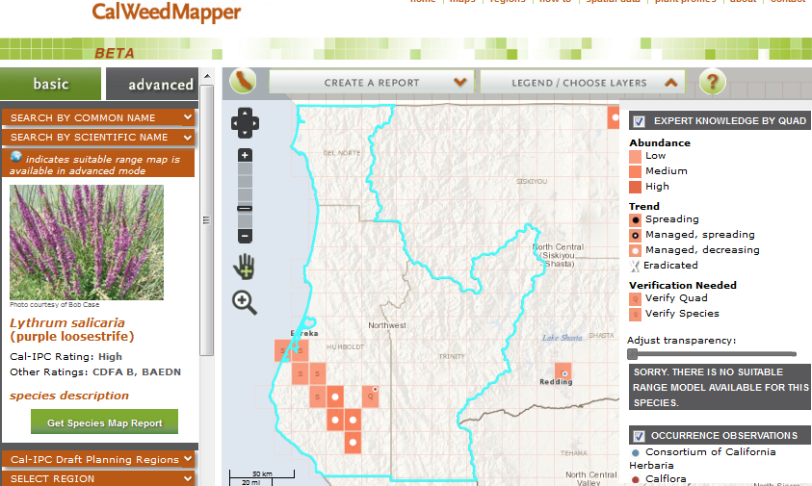

Purple Loosestrife (Lythrum salicaria) Eradication
Prepared by Michelle Forys, California State Parks Environmental Scientist

Total number of sites: 38 miles of river along the South Fork and main stem of the Eel River within Humboldt Redwoods State Park (Figure 1). There could be more down river but no one has surveyed down river from the Park. Surveys up river have been conducted within Humboldt County.
Treatment type: Herbicide is the only way to eradicate this species. There are very few locations where plants are in soil where they can be dug up. Most plants are found attached to river boulders making manual removal impossible.
Total acreage: There are approximately 7,340 individual plants and over 250 infestation sites; if plants are within 30 meters of each other they are considered to be part of one infestation site. It is estimated that all plants combined would be less than 1 acre in size.
Cost per acre to treat: $8,000 to $12,000 per acre (Includes herbicide, fuel for transportation, and salary). This could be high if water quality monitoring is required.
Total cost per year: Year 1 (Environmental Permitting) - $15,000; Year 2 - 5 (Treatment) - $12,000 a year; Year 5 -10 (Treatment and/or monitoring) - $8,000
Number of years to eradicate: 4 to 6
Number of years to monitor: 4 to 6
Total cost to treat $51,000 (5 years), Total cost to monitor, $40,000 (5 years)

Target 6: Tamarix ramosissima (saltcedar, tamarisk)
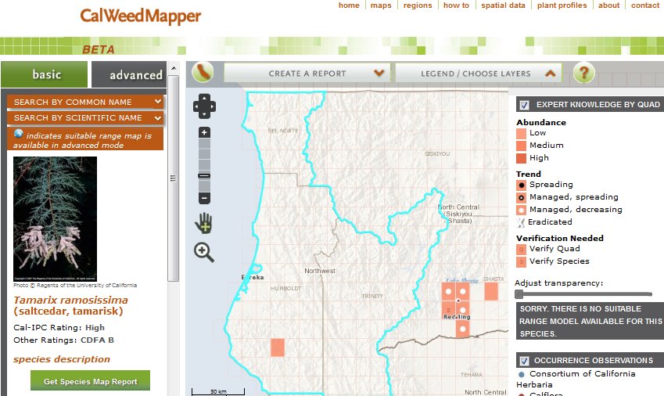
Salt cedar (Tamarisk ramosissima) Eradication
Prepared by Michelle Forys, California State Parks Environmental Scientist

Total number of sites: 1 location within Humboldt Redwoods State Park
Treatment type: Manual removal using chainsaws and hand tools
Total acreage: 0.06 acre, 1 large clump (254 sq. meters) and 1 small individual plant; about 50 meters apart from each other (Figure 1)
Cost to treat initially: $1,000.00
Total cost per year: Year 1 - $1,000; Year 2 - $650, Year 3 - $350; Year 4 to 6 (monitoring) - $200
Number of years to eradicate: 2 to 3
Number of years to monitor: 2 to3
Total cost to treat $2000, Total cost to monitor, $600 (3 years)
Figure 1:
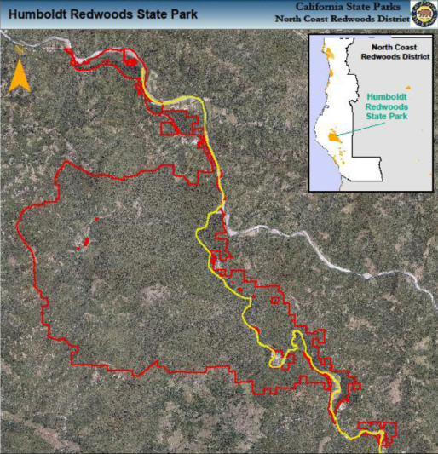
Target 7: Euphorbia virgata (= Euphorbia esula) (leafy spurge)
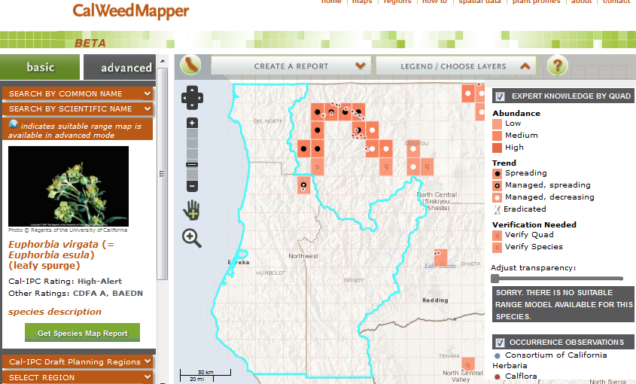
Leafy Spurge (Eurphorbia virgata) Eradication
Prepared by Tanya Chapple, Mid Klamath Watershed Council, tanya@mkwc.org , (530) 627-3202
and Carrie Schreiber, Six Rivers National Forest, cschreiber@fs.fed.us , 707-441-3541
Total number of sites: 7
Treatment type: hand pulling/tarping
Total acreage: <0.5 ac
Cost to initially treat: $1200
Total cost per year: Year 1 - $1200; Year 2 - $1200; Year 3 - $1200; Year 4 to 10 (monitor) - $4500.
Number of years to eradicate: 3 years
Number of years to monitor: 7 years
Total cost to treat $3600 for 3 years; Total cost to monitor, $4500 for 7 years

Notes:
7 total sites (3 mapped in 2012, 3 in 2011 and 1 in 2009, the 2009 sites is potentially eradicated, no plants in 2011&12), one of these sites is on private land, Treatment is hand pulling/digging and tarping with thick black plastic for appropriate sites. We try to treat the leafy spurge twice per season, Total acreage is less than a half an acre. The total number of plants in 2012 is 23, Cost is an estimated $900 for two visits for all the known sites. It would probably be worthwhile to have some extra to continue finding any new sites while they remain small. Two of the sites are difficult to access, no road in the river gorge or on the other side of the river, these will take extra time to get to. My cost estimate includes my guess on time it would take to follow a difficult steep trail, or to safely swim across the river. It may be best to hire a raft as we did for the survey, in which case the cost would go up to at least $1200 per year, Because the sites are all very small, making treatment time pretty minimal, I would expect the cost to be the same for the three years I think it would take to eradicate. The cost would be half for the next 10 years or however long to monitor at only one visit per year.

Target 8: Chondrilla juncea (rush skeletonweed)
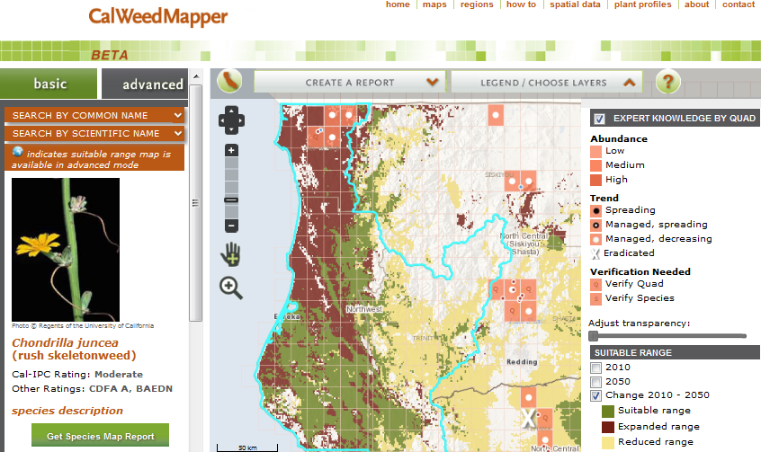

Rush skeletonweed (Chondrilla juncea) Eradication
Prepared by Jim Buckles, Del Norte County Agriculture, jbuckles@co.del-norte.ca.us , 707-464-7235

Total number of sites: few hundred scattered along Hwy 199 at about 5-6 locations
Treatment type: spot treatments
Total acreage: 1
Cost to treat initially: $500
Total cost per year: Year 1 - $500 ; Year 2 - $500 , Year 3 - $500 ; Year 4 to 6 (monitoring) - $ 250
Number of years to eradicate: 3
Number of years to monitor: 5 (but source is Oregon)
Total cost to treat $1500 ( 3 years), Total cost to monitor, $1250 ( 5 years)
Notes: Costs include labor and chemicals. We look for Skeleton weed while we are surveying/treating Meadow knapweeds.

Target #9: Euphorbia oblongata (oblong spurge)
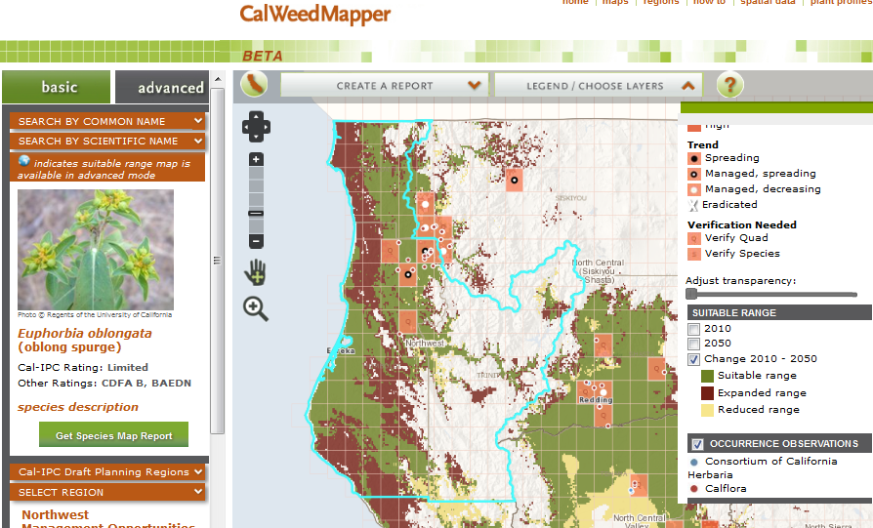
Oblong spurge (Euphorbia oblongata) Eradication
Prepared by Tanya Chapple, Mid Klamath Watershed Council, tanya@mkwc.org , (530) 627-3202 and Carrie Schreiber, Six Rivers National Forest, cschreiber@fs.fed.us , 707-441-3541

Total number of sites: 22
Treatment type: hand pulling
Total acreage: 11.5
Cost to initially treat: $4600
Total cost per year: Year 1 - $ 4600; Year 2 - $4600; Year 3 - $4600; Year 4-$4600; Year 5-$4600; Year 1 to 5 (monitor) - $3400 per year.
Number of years to eradicate: 5 years
Number of years to monitor: 5 years
Total cost to treat $23,000 for 5 years total; Total cost to monitor, $ 17,000 for 5 years total

OTHER SPECIES INVESTIGATED AND DETERMINED TO NOT BE ERADICABLE:
Centaurea maculosa (spotted knapweed)- not eradicable, Carrie S. and Tanya C.
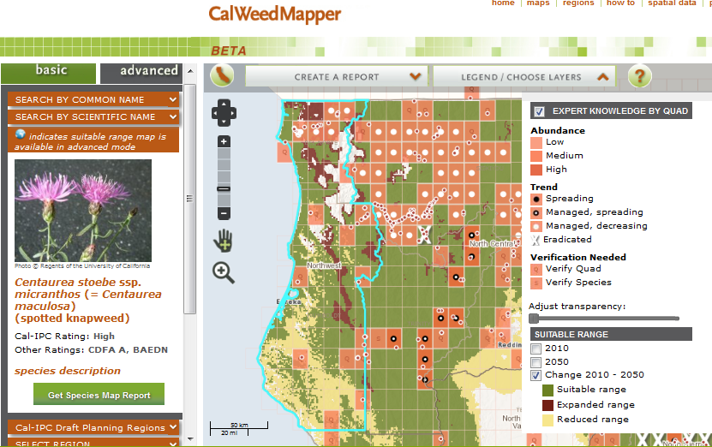

Centaurea diffusa (diffuse knapweed)- not eradicable, Carrie S. and Tanya C.
