ERADICATION WORKPLAN for NORTH CENTRAL – 2013
Regional stakeholders determined that the species listed below are eradicable from the North central region (Siskiyou, Shasta & Trinity counties) within five years. This document describes the proposed management and cost necessary for eradication of these species. Send questions to mapping@cal-ipc.org or call 510-843-3902.

 | SPECIES |  |  | COMMON NAME | LINK TO MAP
ERADICATION TARGETS | 1 | Centaurea jacea nothossp. pratensis (= Centaurea debeauxii) | meadow knapweed |  | CalWeedMapper: Centaurea jacea nothossp. pratensis (= Centaurea debeauxii)
ERADICATION TARGETS | 2 | Chondrilla juncea | rush skeletonweed |  | CalWeedMapper: Chondrilla juncea
ERADICATION TARGETS | 3 | Euphorbia oblongata | oblong spurge |  | CalWeedMapper: Euphorbia oblongata
ERADICATION TARGETS | 4 | Fallopia japonica (= Polygonum cuspidatum) | Japanese knotweed |  | CalWeedMapper: Fallopia japonica (= Polygonum cuspidatum)
ERADICATION TARGETS | 5 | Salvia aethiopis | Mediterranean sage |  | CalWeedMapper: Salvia aethiopis
ERADICATION TARGETS | 6 | Sesbania punicea | red sesbania, scarlet wisteria |  | CalWeedMapper: Sesbania punicea
ERADICATION TARGETS | 7 | Cynara cardunculus | artichoke thistle |  | CalWeedMapper: Cynara cardunculus
ERADICATION TARGETS | 8 | Carduus acanthoides | plumeless thistle |  | CalWeedMapper: Carduus acanthoides

I. PRIORITY targets. Each species is described by total number of sites, treatment type, total acreage (or total number of plants if small), cost per acre to treat, total cost per year, # of years to eradicate:, and # of years to monitor. The intent is to have these species generally mapped by quad in CalWeedMapper and to have each occurrence mapped in Calflora (as a point, line or polygon). If detected in new areas, the species should be mapped and targeted for eradication. Regional partners will mobilize to respond rapidly and remove it.
Ii. Regional AREAS OF CONSERVATION EMPHASIS: These represent areas of high “biological richness” within the region, defined by biodiversity, rarity, irreplaceability and presence of sensitive habitats. 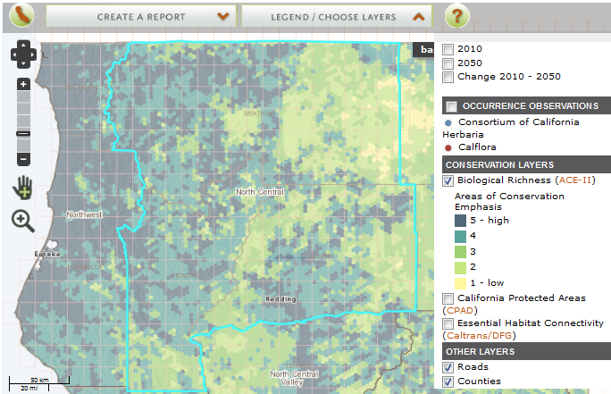
Target 1: Centaurea jacea nothossp. pratensis (meadow knapweed)
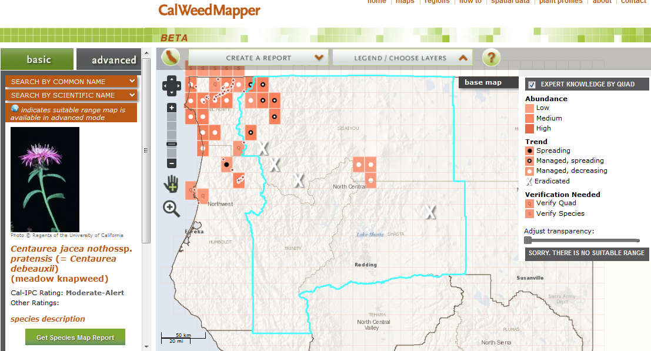
Centaurea jacea nothossp. Pratensis (meadow knapweed) Eradication
Prepared by Jodi Aceves, Siskiyou County Agriculture, jaceves@co.siskiyou.ca.us, (530) 841-4115, Marla Knight (&Erin Rentz), Klamath National Forest, maknight@fs.fed.us , 530.841.4425, Tanya Chapple, MKWC & Petey Brucker, SRRC
Eradication Targets, North/Central Siskiyou County, for comment, 1/8/2013.
 | Meadow Knapweed: Federal | Meadow Knapweed: Private
Total number of sites: | 14 | 10*
Treatment type: | hand pull/dig | Herbicide: Milestone, Glyphosate
Total net acreage: | 3.5 | 2.02
Gross acreage: | 9.9 | 684.3
Cost/acre: | $1,000 | $120
Total cost per year: Year 1 - | $3,500 | $242
Total cost per year: Year 2 | $3,500 | $242
Total cost per year: Year 3 | $3,500 | $242
Total cost per year: Year 4 | $2,500 | $242
Total cost per year: Year 5 | $2,500 | $242
Year 6 to X (spot treat/monitor ) - cost/year | $1,000 | 0
Number of additional years (over 5) to eradicate: | 5 | 0
Years to eradicate | 10 | 5
Total cost to eradicate | $20,500 | $1,210
Year X to X post eradication (monitor) - cost/year | $1,000 | $245
Number of years to monitor: | 10 | 10
Total cost to monitor ( 10 years) | $10,000 | $2,450
GRAND TOTALS:
Total cost eradication and monitor | $30,500 | $3,660
Total years, eradication and monitor | 20 | 15
Notes: Erin provided Federal acres from GIS; KNF has 23 meadow knapweed sites listed: 13 federal, 10* private, includes Indian Creek and Salmon River. Tanya provided plumeless cost estimates, and comments that there are probably more oblong spurge sites to be found along the Klamath. Petey echos that for the Salmon, below Indian Bottom.
Assumptions: field worker rate= $17.00/hr includes benefits; Federal net acres are estimates; costs for manual oblong spurge doubled per coordination meeting.

Notes:
General: A lofty goal. We can only hold the leading edge, because the source is Del Norte who is not treating it and Oregon who is also a source. Hopefully the landforms of mountains and roadsides hold the line. If we could work on it with herbicides it could work. Many of the sites are riparian and near water so it will be difficult to get permission.

Jodi: Increasing in Happy Camp area. In 2007 there was 1.26 acres and now in 2012 there is 4 acres.

Petey & Tanya: Tanya has been working closely with MKWC to manage the mentioned Happy Camp and also Weithpec populations. There could be a bit of work associated with these and MKWC could probably be helpful if consulted on the draft amounts based on labor and tools.
In the North Central Region the SRRC deals with 3 eradicated populations of meadow knapweed in the Salmon River. 1 in Somes Bar at .04 mile marker on Highway 96. This population should be monitored 2 or 3 times in 2013 and 2014 to make sure it is going, going and eradicated. The other 2 populations are one on the North Fork of the Salmon River - up from where the mining is taking place at the Yellow Jacket Mine - It should be looked at 1-2 times to insure eradication is occurring; and the third site was at Sam George's - on the county roadside - we haven't seen a meadow knapweed there for about 10-12 years. I believe we saw one at Black Bear ranch, in the garden, about 10-12 years ago. It was immediately dug up and it disappeared. It would be good to maintain these 3 sites, as well as to insure that no new sites are occurring on private, public or tribal lands too.

Target 2: Chondrilla juncea (rush skeletonweed)
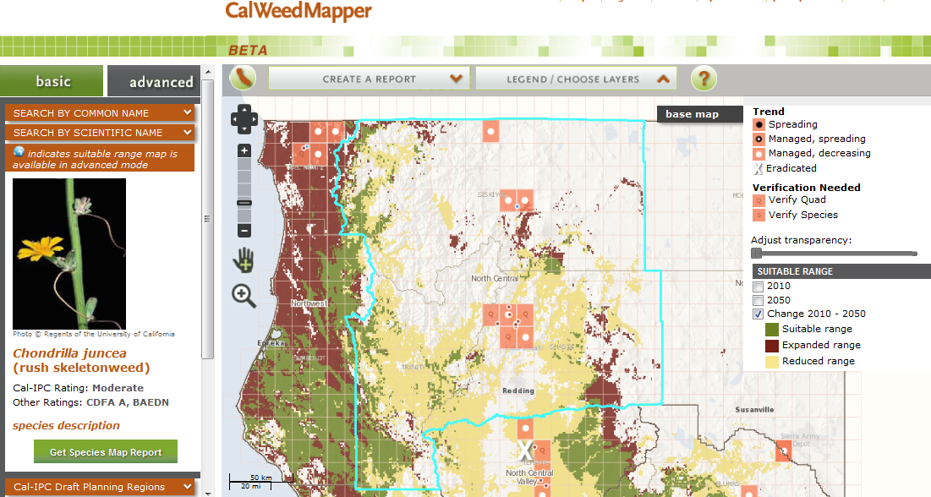
Rush skeletonweed (Chondrilla juncea) Eradication
Prepared by Jodi Aceves, Siskiyou County Agriculture, jaceves@co.siskiyou.ca.us, (530) 841-4115

Along I-5, Siskiyou County
Total number of sites: two along I-5 & one at Lake Shastina. Work in partnership with Caltrans
Treatment type: herbicide: Gyphosate
Total acreage: .5 acres net, 5 acres gross (~$500/acre)
Cost to initially treat:
Total cost per year: Year 1 - $2500; Year 2 - $2500, Year 3 - $2500; Year 4 to 6 (spot treat) - $1250/yr
Number of years to eradicate: 5 years
Number of years to monitor: 10 years

Total cost to treat: $12500 ( 6 years), Total cost to monitor: $ (indef. until source populations in OR are gone)

Prepared by Paul Kjos, Shasta County Agriculture, pkjos@co.shasta.ca.us , (530) 224-4914

Along I-5, Shasta County
Total number of sites: one large site – 99% of plants confined to I-5 corridor along CalTrans ROW
Treatment type: chemical
Total acreage: 375 acres gross , 22 acres net
Cost to initially treat: $ 19,500
Total cost per year: Year 1 -$ 6,500; Year 2 - $ 5,500; Year 3 - $ 4,500; Year 4 - $ 3,000 Year 5 to 8 (spot treat/monitor ) - $ 2,500/year ; Year 9 to 10 (monitor) - $1,500/year .
Number of years to eradicate: 4 years
Number of years to monitor: 6 years

Total cost to treat $19,500 (4 years), Total cost to monitor, $ 13,000 (6 years)

Prepared by Philip Brownsey(& Lusetta Nelson), Shasta-Trinity National Forest, pbrownsey@fs.fed.us, (530) 226-2432

8 miles west of Antlers Bridge project on I-5
Total number of sites: 5, 2 on private & 3 on public
Treatment type: mixed herbicide or hand pull
Total acreage: gross 0.17 acres
Cost to initially treat: $
Total cost per year: Year 1 -$ ; Year 2 - $; Year 3 - $; Year 4 - $ Year 5 to 8 (spot treat/monitor ) - $ ; Year 9 to 10 (monitor) - $ .
Number of years to eradicate: 4 years
Number of years to monitor: 6 years

Total cost to treat $ ( years), Total cost to monitor, $ ( years)
Notes:
Siskiyou, Jodi: Road department Siskiyou treats county and state roads (through Caltrans) and surveil for it. Veg management supervisor takes notes and crew treats all known sites. Can be every quad along I-5, a continual reinfesting from Oregon. Find it on the southbound lane.
Shasta, Paul: We have contracts with CalTrans for noxious weed control within their ROW and use these funds to control the skeletonweed along I-5. Any plants we find outside the ROW, we treat using county funds.

Target 3: Euphorbia oblongata (oblong spurge)
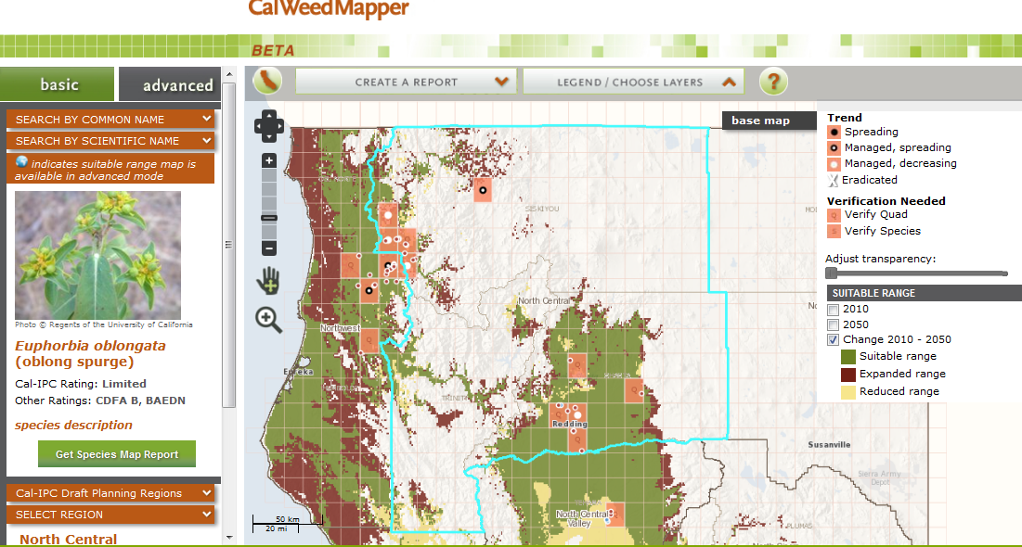
Oblong spurge (Euphorbia oblongata) Eradication
Prepared by Paul Kjos, Shasta County Agriculture, pkjos@co.shasta.ca.us , (530) 224-4914

Shasta County area
Total number of sites: 7
Treatment type: chemical
Total acreage: 55 gross acres, 5 net acres
Cost to initially treat: $6,000
Total cost per year: Year 1 -$5,000; Year 2 - $5,000; Year 3 - $2,000 ; Year 4 to 6 (spot treat/monitor ) - $2,000 ; Year 7 to 10 (monitor) - $1,500
Number of years to eradicate: 4 years
Number of years to monitor: 6 years

Total cost to treat $ 18,000 ( 4 years), Total cost to monitor, $ 12,000 ( 6 years)

Prepared by Philip Brownsey(& Lusetta Nelson), Shasta-Trinity National Forest, pbrownsey@fs.fed.us, (530) 226-2432

Lake Shasta area
Total number of sites: 3
Treatment type: hand pulling
Total acreage: gross ,net 0.1 acres ($20,000/year)
Cost to initially treat: $
Total cost per year: Year 1 – 4 (treat) $2,000/yr; Year 5 to 10 (monitor) - $1000/yr.
Number of years to eradicate: 4 years
Number of years to monitor: 5 years

Total cost to treat: $8000 (4 years), Total cost to monitor: $5000 (5 years)
Prepared by Jodi Aceves, Siskiyou County Agriculture, jaceves@co.siskiyou.ca.us, (530) 841-4115, Marla Knight (&Erin Rentz), Klamath National Forest, maknight@fs.fed.us , 530.841.4425, Tanya Chapple, MKWC & Petey Brucker, SRRC
Eradication Targets, North/Central Siskiyou County, for comment, 1/8/2013.
 | Oblong Spurge: Federal (Salmon R.) | Oblong Spurge: Private | Oblong Spurge: Private (Klamath R.)
Total number of sites: | 3 | 1 | 1 or more
Treatment type: | hand pull/dig | Herbicide | hand pull/dig
Total net acreage: | 2.7 | 0.5 | 1
Gross acreage: | 15 | 5.0 | 11
Cost/acre: | $700 | $500 | $727
Total cost per year: Year 1 - | $10,500 | $250 | $8,000
Total cost per year: Year 2 | $9,000 | $250 | $6,000
Total cost per year: Year 3 | $8,000 | $250 | $5,000
Total cost per year: Year 4 | $7,000 | $250 | $4,000
Total cost per year: Year 5 | $6,000 | $250 | $3,000
Year 6 to X (spot treat/monitor ) - cost/year | $1,000 | 0 | $1,000
Number of additional years (over 5) to eradicate: | 2 | 0 | 2
Years to eradicate | 7 | 5 | 7
Total cost to eradicate | $42,500 | $1,250 | $28,000
Year X to X post eradication (monitor) - cost/year | $1,000 | $250 | $500
Number of years to monitor: | 10 | 10 | 10
Total cost to monitor ( 10 years) | $10,000 | $2,500 | 5000
GRAND TOTALS:
Total cost eradication and monitor | $52,500 | $3,750 | $33,000
Total years, eradication and monitor | 17 | 15 | 17
Notes: Erin provided Federal acres from GIS; KNF has 23 meadow knapweed sites listed: 13 federal, 10* private, includes Indian Creek and Salmon River. Tanya provided plumeless cost estimates, and comments that there are probably more oblong spurge sites to be found along the Klamath. Petey echos that for the Salmon, below Indian Bottom.
Assumptions: field worker rate= $17.00/hr includes benefits; Federal net acres are estimates; costs for manual oblong spurge doubled per coordination meeting.
These figures estimates, pending confirmation with mapping from SRRC.
Original net/gross acres of Federal spurge, Salmon R: 1.7/2.1

Notes:
Tanya: I have heard rumor of oblong spurge on other private properties in Somes Bar. I have not seen it, to eradicate the oblong will take significant outreach to the landowners on the river bars.
Siskiyou Ag worked with MKWC and they will continue to work together to help landowner eradicate it. The white dots are the ones along the Klamath where they were found and treatment was hand pulling.
We do use a lot of volunteers in our normal operations, I did not include any volunteers in my estimations. I decided I would give you figures based on how much effort it would take our paid staff to achieve these goals - eradication. But that said, volunteers and residents will likely be involved in work on Oblong spurge which may amplify the effort and we could achieve these goals sooner.
Petey: We have been spending several days and lots of boating associated with the oblong spurge sites we have on the lower Salmon River. Tanya probably has some insight and costs ( peoples time, tools, etc, ) into the mid-Klamath River sites as well. We can cost these activities out to meet the timeline for eradication on both the Salmon River and the Mid Klamath.

Target 4: Fallopia japonica (Japanese knotweed)
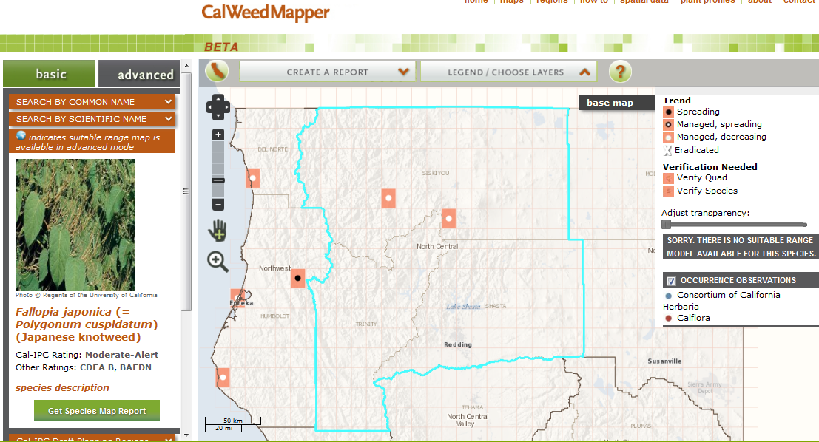

Japanese knotweed (Fallopia japonica) Eradication
Prepared by Jodi Aceves, Siskiyou County Agriculture, jaceves@co.siskiyou.ca.us, (530) 841-4115

Mt. Shasta and Etna quads
Total number of sites: 2
Treatment type: Glyphosate injection
Total acreage: .2 acres (~$1000/acre to treat)
Cost to initially treat:
Total cost per year: Year 1 - $200; Year 2 - $ 200 , Year 3 - $200; Year 4 to 5 (spot treat) - $400; Year 6-15 (monitor) - $
Number of years to eradicate: 5 years
Number of years to monitor: 10 years

Total cost to treat $1000 (5 years), Total cost to monitor $ (10 years)

Notes:

Target 5: Salvia aethiopis (Mediterranean sage)
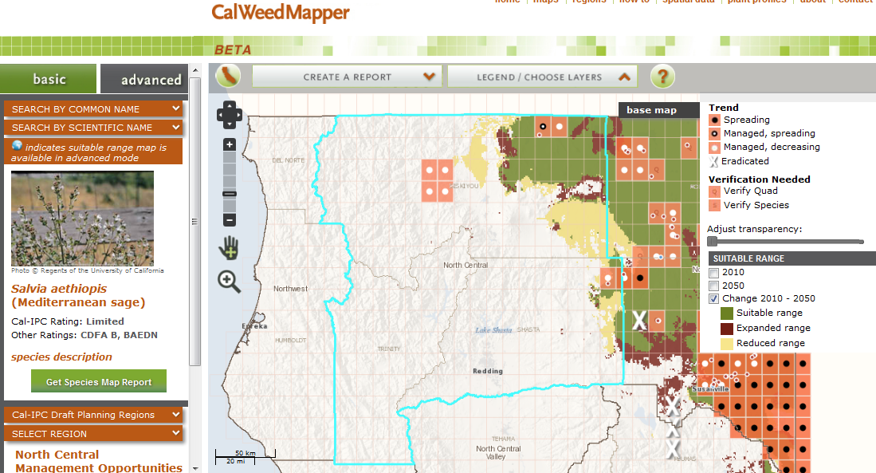
Mediterranean sage (Salvia aethiopis) Eradication
Prepared by Kelly Shuler, Fall River RCD, shuler@citlink.net , (530)336-6591

Fall River Mills Quad Area
Total number of sites: Area is located on northeastern area of Fall River Lake. The RCD mapped and divided quadrants for treatment. 2010 area was mapped and eradication begun. 2011 PGE land was treated. 2012 only one quadrant was treated due to lack of funding. This area should never have been allowed to become so infested! It has been known about for years and nothing done until the RCD was given an ARRA grant and they began work.
Treatment type: digging rosettes/ pre bloom, hand crew w/ shovels *
Total acreage: ~87 gross acres on PGE property, ~3 acres on private
Cost to initially treat:
Total cost per year: Year 1 - $3,000 ; Year 2 - $3,000; Year 3 - $3,000; Year 4 -10 $1,000/yr (spot treat/monitor ); Year 11 to 14 (monitor) - $ 600.00/yr.
Number of years to eradicate: 10 years
Number of years to monitor: 3 years

Total cost to treat $ 15,000 (10 years), Total cost to monitor** $ 1800.00 (3 years)
* grasses/broadleaves, shrubbery prevent chemical use.
** Yr.1-10 monitoring would be taking place at time of treatment, and spot treatment

Prepared by Jodi Aceves, Siskiyou County Agriculture, jaceves@co.siskiyou.ca.us, (530) 841-4115
Area 1: Indian Creek Baldy, Yreka, Fort Jones and Duzel Rock quad
Area 2: Dorris and Sheepy Lake quad (Butte valley)
Total number of areas: 2
Treatment type: herbicide: Telar, $772/acre
Total acreage, area 1: 3020 gross acres, 3.67 net infested acres
Total acreage, area 2: 1 net infested acre
Cost to initially treat:
Total cost per year: Year 1 – 5: $2833/year; Year 6 to 15 (spot treat & monitor) - $
Number of years to eradicate: years
Number of years to monitor: years

Total cost to treat $14,166.20 (5 years), Total cost to monitor, $ ( years)

Notes:

Target 6: Sesbania punicea (red sesbania, scarlet wisteria)
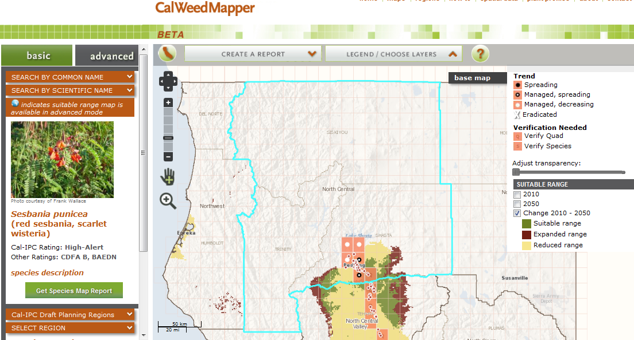
Red sesbania (Sesbania punicea) Eradication
Prepared by Paul Kjos, Shasta County Agriculture, pkjos@co.shasta.ca.us , (530) 224-4914

Total number of sites: many sites along Churn Creek, four other known sites under treatment, two other sites being monitored
Treatment type: manual removal, chemical treatment
Total acreage: 500 + acres gross
Cost to initially treat: $75,000
Total cost per year: Year 1 - $45,000 ; Year 2 - $ 40,000 ; Year 3 - $ 15,000 ; Year 4 - $15,000 ; Year 5 to 10 (spot treat/monitor ) - $12,000/year; Year 11 – 20 (monitor) - $ 5,000/year.
Number of years to eradicate: 10 years
Number of years to monitor: 10 years

Total cost* to treat $ 250,000 (10 years), Total cost to monitor, $ 50,000 (10 years)
*Monies listed above do not include the cost of NPDES permit and required reporting

Target 7: Cynara cardunculus (artichoke thistle)
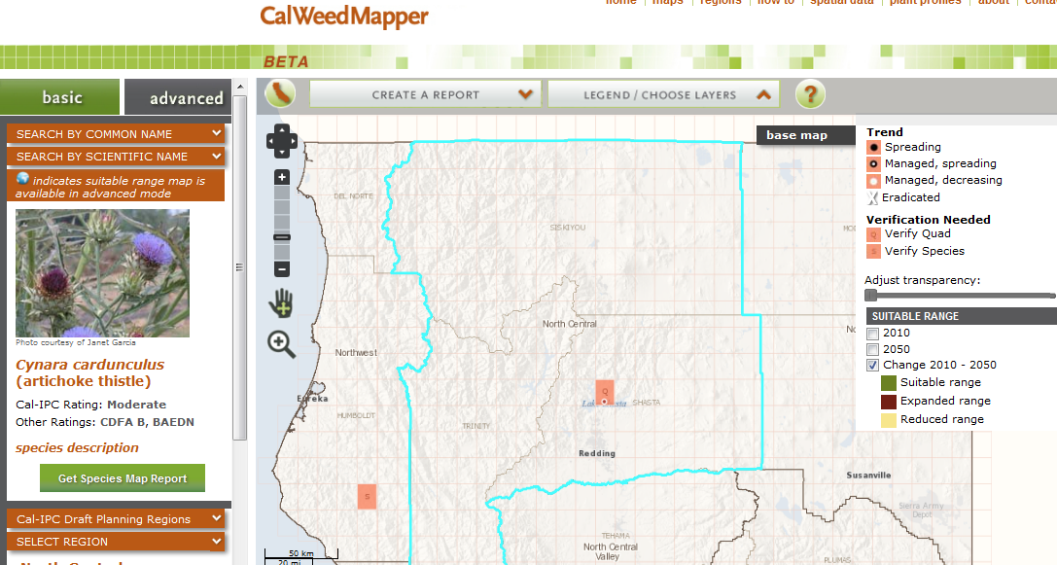Artichoke thistle (Cynara cardunculus) Eradication
Prepared by Paul Kjos, Shasta County Agriculture, pkjos@co.shasta.ca.us , (530) 224-4914

Total number of sites: 1
Treatment type: monitor, manually remove any sprouts
Total acreage: 1.5 acre gross
Cost to initially treat: $200
Total cost per year: Year 1 to 5 (spot treat/monitor ) - $1,000 ; Year 6 to 10 (monitor) - $ 1,000
Number of years to eradicate: 5 years
Number of years to monitor: 10 years

Total cost to treat/monitor, $ 2,000 (10 years)

Notes:

Target 8: Carduus acanthoides (plumeless thistle)
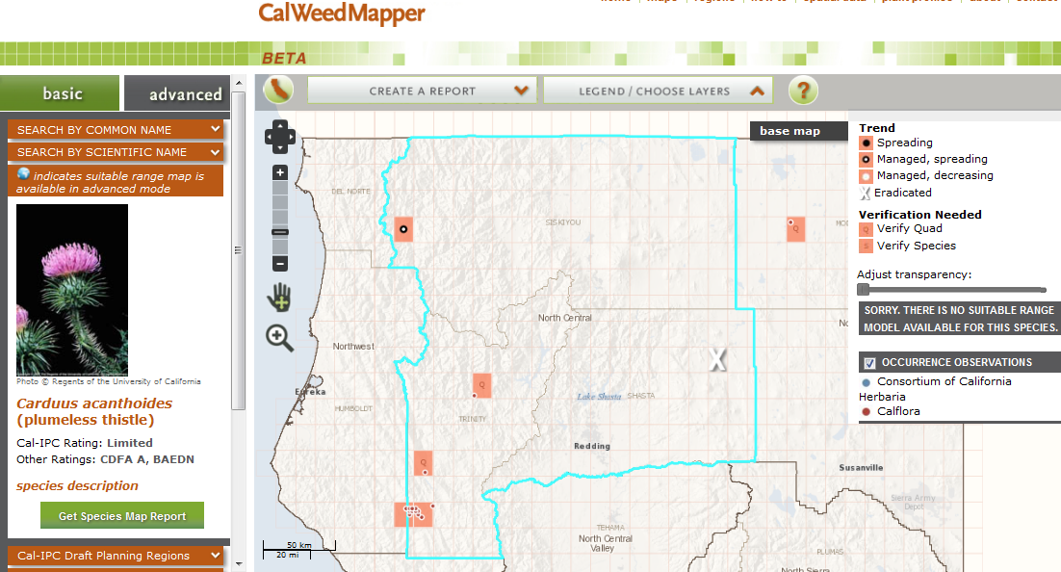
Plumeless thistle (Carduus acanthoides) Eradication
Prepared by Tanya Chapple, MKWC & Marla Knight, Klamath National Forest, maknight@fs.fed.us , 530.841.4425

Eradication Targets, North/Central Siskiyou County, for comment, 1/8/2013.
 | Plumeless Thistle
Total number of sites: | 1
Treatment type: | hand pull/dig
Total net acreage: | 5.0
Gross acreage: | 5.0
Cost/acre: | $400
Total cost per year: Year 1 - | $2,000
Total cost per year: Year 2 | $2,000
Total cost per year: Year 3 | $2,000
Total cost per year: Year 4 | $1,000
Total cost per year: Year 5 | $1,000
Year 6 to X (spot treat/monitor ) - cost/year | $500
Number of additional years (over 5) to eradicate: | 5
Years to eradicate | 10
Total cost to eradicate | $10,500
Year X to X post eradication (monitor) - cost/year | $500
Number of years to monitor: | 10
Total cost to monitor ( 10 years) | $5,000
GRAND TOTALS:
Total cost eradication and monitor | $15,500
Total years, eradication and monitor | 15
Notes: Tanya provided plumeless cost estimates, and comments that there are probably more oblong spurge sites to be found along the Klamath. Petey echos that for the Salmon, below Indian Bottom.
Assumptions: field worker rate= $17.00/hr includes benefits;

Suggested additions as eradication targets with Trinity County joining us. We want 10 total.
Trinity/Shasta county:
- Arundo donax- ask Randy Smith, <$100k for eradication? Paul Kjos: this would be a question for Randy Smith but I don’t think it would take that much since the Rotary Stream Team has knocked it way back already.
- Anthoxanthum odoratum
- Carduus nutans (musk thistle) – priority when Trinity was a part of the NW region, was in Trinity County only
- Centaurea virgata ssp. squarrosa (squarrose knapweed) – priority when Trinity was a part of the NW region, was in Trinity County only
- Onopordum acanthium (Scotch thistle) – priority when Trinity was a part of the NW region, was in Trinity County only
Siskiyou county/Shasta county (not sure about Trinity):
- Centaurea calcitrapa (Purple starthistle)- in Siskiyou: .16/2, 300 acres $1,293/acre , $1035 over 5 years , Herbicides use : Milestone & not being worked on in Shasta
- Physalis subglabrata (smooth ground cherry)- in Siskiyou: .01/280 acres $3,441/acre , $172 over 5 years , Herbicides use : Milestone & unknown in Shasta
- Onopordum tauricum (Taurian thistle) - in Siskiyou: .16/875 acres $2,900/acre , $2345 over 5 years , Herbicides use : Milestone& unknown in Shasta
- Leafy spurge containment in Siskiyou: The waterways are such a huge vector of spread. With a natural system, it’s a hard one to contain. I think it only comes downstream a tiny way and it gets sparser and sparser as you go downstream.
- Petey: As the current draft Strategic Plan also prioritizes, we probably should take care of the few jubata grass plants,the yellow toadflax (assuming dalmation included in this) and possibly the cutleaf teasel populations that we have either been or could manage and push these prioritized species towards eradication in the Salmon River and on the Mid Klamath River watershed.
Removed from regional eradication list:
- Halogeton - Siskiyou Ag- Historic listing in Cal-IPC web site, vouchered by CDFA: Juniper Flat quad (Hwy 97, 0.5 m S of A12)-is it still there? Jodi: This site=Eradicated.
  - To do: Jodi to update Q quad in CalWeedMapper.
Outreach
- Petey: We also may want to support some outreach and education activities and products or Oblong Spurge in Siskiyou County including the Mid-Klamath River and Salmon River areas. . .

