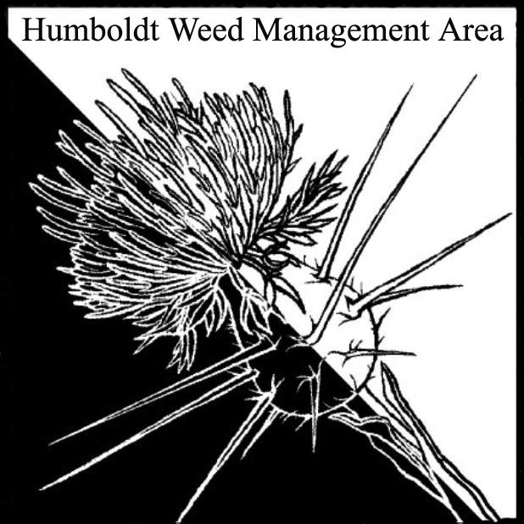
HWMA
Steering Committee Meeting
Tuesday, January 16, 2018
BLM Large Conference Room
1:00 – 3:00 PM

Meeting Minutes

- Welcome: Bryan Atkinson and Amy Eberwein, Co-Chairs

Introductions (meeting participants): Bryan Atkinson, Humb Co. Ag; Amy Eberwein, NRS-RCAA; Lisa Hoover, USFS; John Summers, MRC; Jennifer Wheeler, BLM; Janelle Deshais, CDFW; Amy Livingston, GHD; Stephanie Klein, CNPS.

Approval of Minutes: Minutes from the last meeting on September 18, 2017 were approved.

Invitations to Join HWMA: Bryan contacted Del Norte Agriculture Department and they would like to be involved with HWMA via teleconferences during regular meetings. No response from Smith River Alliance as of this meeting. Lisa Hoover volunteered to pass on information about the upcoming meeting to key members of SRA.

HWMA Website Updating: Cal-IPC has provided access to the HWMA page of the Cal-IPC website. Amy Eberwein can now make changes to the page and has requested info on new projects, announcements and other pertinent information from Steering Committee members be sent to her to add to the website.

- Bylaws Revision: The group reviewed the final draft of the revised bylaws. Two small suggestions were made on formatting. John Summers motioned to approve the revised bylaws pending recommended edits. Lisa Hoover seconded. All were in favor. Amy Eberwein will make edits and send out to the group via email.

- Arctotheca calendula (Capeweed) Update: This topic was tabled until the next meeting as key Steering Committee members were unable to attend this meeting. Amy Eberwein suggested that known sites should be added to the Calflora database.

- Humboldt County General Plan: In depth discussion regarding proposed adoption of a change to the Humboldt County General Plan Section BR-S13- Principally Permitted Accessory Use which reads: Invasive plant species management and control measures shall be considered a principally permitted accessory use in all zones, except in the Coastal Zone. While the General Plan was recently adopted; the Supervisors elected to defer for adoption of coastal zone planning changes for inclusion in the Local Coastal Plan amendment that the County is embarking on. Further opportunity will likely be available to comment on the proposed local coastal plan amendment regarding adoption of the change within BR-S13. Amy suggested that HWMA members attend an upcoming Board of Supervisors meeting to speak out against the inclusion of “except in the coastal zone”.

- Round Robin (informal member reports)
Jennifer Wheeler: Recently presented at the Sequoia Zoo. Great turnout. Received an offer for free coverage on Humboldt Access TV for the HWMA regarding a potential series on local, invasive plant species. Jennifer passed around a third edition of the Invasive Weeds of Humboldt County booklet that Domenic (CalTrans) has been working on. BLM has funding for weed program work in 2018. General discussion regarding common and misunderstood definitions and implications of the word ‘naturalized’- just because an introduced plant can successfully reproduce and survive in an area (the most basic meaning of naturalized), does not exclude it from also being classified as an invasive, non-native plant in the absence of ecological checks and balances. Also, general discussion that in many vegetation management contexts, native plants can be treated as ‘weeds’ when they are not contributing to meeting vegetative community objectives. Future restoration descriptions in coastal grasslands, oak woodlands, or coastal dunes should be clear about what types of native plants would be considered targets for removal in meeting vegetation management objectives.

- John Summers: New broom near Capetown on county road. Scotch broom mite is now in CA. There is a website to document mite sightings. Aceria genus- very species specific. Been pulling a few pampas grass in Petrolia but the numbers are very low. Will send an invite to join the HWMA to Sandy Miles from Sanctuary Forest Institute. They are spearheading pampas removal in Shelter Cove.

- Janelle Dechais: New representative from CDFW. Wants to learn how CDFW can be involved in HWMA. Discussion about what invasive plant species could be incorporated into timber harvest plans.

- Stephanie Klein: Not much happening with weeds work. She was able to comment on the NPS plan.

- Lisa Hoover: Trying to get collaborative projects to integrate invasive plant removal rather than as mitigation or after project work.

- Amy Livingston: New attendee from GHD. Looking for suggestions for a non-native, perennial grass that would work well for an erosion control project in a coastal area. Group recommended Poa pretensis.

- Bryan Atkinson: Buffalobur (Solanum rostratum) recently found in agricultural field. Believed to have come from birdseed potentially. New thistle reported in Honeydew. CDFA is interested in more reports on this thistle. It has been removed from the property. CNPS nursery is moving to Freshwater. Compliance, using local seeds.

- Domenic Bongio: (Update provided by Amy Eberwein) Stay on power tool use by contract crews was appealed and the stay has been lifted. Caltrans may now resume using CCC’s and inmates with power tools. Unable to get the fall 2017 treatment of shining geranium down due to lack of spray truck. The population was probably down to 1 – 3% of what it was in May 2017. Will not treat again until spring 2018.

- Amy Eberwein: Several new Arundo donax sites located in King Salmon and Field’s Landing. CDFA requested more herbarium specimens of invasive plants species encountered in this area.

III. Next HWMA meeting
Next meeting set for Monday, April 16th, 2018 from 1 – 3 p.m. at the Arcata USFWS Office small conference room.

