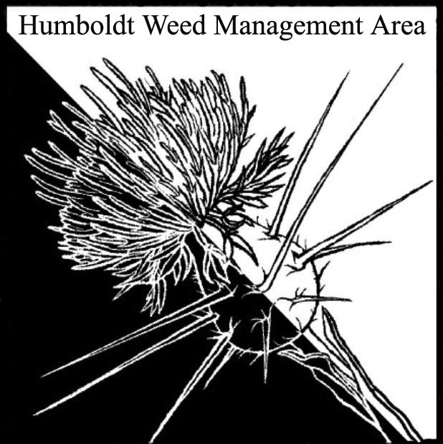
HWMA
Steering Committee Meeting
Monday, June 19, 2017
BLM Large Conference Room
1:00 – 3:00 PM

Minutes

- Welcome: Bryan Atkinson and Amy Eberwein, Co-Coordinators (1:00)

Introductions (meeting participants): Jennifer Wheeler, BLM; Bryan Atkinson, Humb Co. Ag; Madeline Hassett, BLM intern; Domenic Bongio, Caltrans; Judy Haggard, MLT; Craig Benson, NRS-RCAA, Amy Eberwein, NRS-RCAA; Doyle Doss, local resident; Jenny Hutchinson, USFWS and TCLT; Clint Pogue, USFWS; Steen Trump, TCLT.

Approval of Minutes: Minutes from the last meeting on March 20, 2017 were approved.

Funding update: Recent attempts to secure funding for state WMA’s were not successful. Cal-IPC has now hired an environmental lobbying firm to explore multiple funding angles for priority invasive plant management projects.

Calendar: Input was requested for techniques on maintaining a HWMA calendar that is accessible to all. Ideas included providing calendar notices with each HWMA associated email, and the development of a HWMA specific website to house the calendar.
* Agenda item: Assessment of potential website

Revising Bylaws: There are changes that need to be made in the wording (including which organizations are involved). The bylaws will be sent out prior to the next meeting for review. In addition, it was discussed that the Del Norte County WMA is not currently active and there is potential to combine them with our WMA.
*Agenda item: Assessment of necessary changes to current bylaws
- New Members- USFWS: (1:30)
USFWS has three new botanists and are interested in attending HWMA meetings regularly as steering committee members. An MOU is already signed.

- Trinidad Coastal Land Trust: (1:40)
USDA recently approached TCLT with a proposal for a field study on Cape Ivy on their property near Moonstone Beach. This study would involve the release of the Cape Ivy tip-galling fly that is known to be a predator and biological control of Cape Ivy. Field studies have shown that this species does not attack any other plant species. TCLT asked for input on this proposal.

The issue of creating a working group to battle invasive plants in the Trinidad area was again discussed. With limited funding and low chance of success it was determined that this is not a task that can be taken on by the HWMA at this time.

- Pulling Together Initiative Grant Opportunities: (2:15)
The National Fish and Wildlife Foundation is accepting pre-proposals for the Pulling Together Initiative. Funding opportunities apply to existing WMA’s for capacity building. Amy Eberwein will contact WMA partners to verify that applying for this grant will not create competition amongst partners. A subcommittee was developed to work on this pre-proposal and includes Amy Eberwein, Bryan Atkinson, Craig Benson and potentially Dana Morowitz. The proposal from HWMA would be for capacity building including the development of a website and expanding outreach capabilities.

- HWMA Media:
Discussion continued from previous meeting as to methods of outreach in the community including theater ads, PSA’s, hiring a consultant for ad campaign, developing a “viral” message video, using social media, creating a mascot. These ideas could be implemented as part of the potential PTI grant proposal.

- Humboldt County Fair Prep:
Planning for this year’s county fair booth. Volunteers are: Stassia Samuels, Bryan Atkinson, Jenny Hutchinson, Madie Hassett, and Domenic Bongio. Bryan will submit the application.

- Round Robin (informal member reports) (2:30)
- Dana Morowitz (via Amy Eberwein): This year’s Cal-IPC symposium is October 24 – 27 in Palm Springs, California.
- Amy Eberwein: Increase in shining geranium sites, requesting others to search for it. Work is continuing on the WCB eradication project.
- Jennifer Wheeler: Continuing work on a variety of projects. Some funding set aside for next year in the event that there is no funding available.
- Maddie Hassett: Has been working with CCC’s at Trinidad Head pulling Ivy. There will be two more spring sessions.
- Craig Benson: WCB project recap. Spartina treatment update- 450 acres now treated. Prop 1 funding secured for a Marsh Master and additional treatments. Discussed mulching techniques for yellow star thistle.
- Doyle Doss: Discussed his involvement with removing fennel and pampas grass from the Hikshari’ trail. Wants to learn more about the HWMA and how to engage the public in participating more in invasive plant removal.
- Jenny Hutchinson: USFWS has been working on removing invasive mustard in Manila. The numbers are down significantly. Discussed removal of hybrid primrose on TCLT property. There is a rare species that also occurs on the property.
- Clint Pogue: Continued the discussion of invasive mustard removal in Manila. Laurel Goldsmith has been tracking the data on this project. This species is considered eradicable and could be eligible for funding opportunities.
- Steen Trump: There has been a reduction in the amount of volunteers available from HSU for Ivy Bash workdays due to the Natural Resources club working closely with the City of Arcata. Significant movement of ivy from Moonstone to Pilot Point. Replanting has been taking place at after a fire that occurred on Houda Point.
- Domenic Bongio: Has been working with CCC’s this year on invasive pulling. Discussed some internal court issues which may lead to inmate crews and CCC’s not being able to use power tools in the future. Continued work on Ivy and Broom removal. Update on knotweed sites- all are decreasing. Update on shining geranium- missed fall treatment due to truck under maintenance and rains. Massive increase in the size of all infestations and some new sites found. Information on available Port Orford Cedar seed and seedlings that are resistant to POC disease.
- Judy Haggard: Continuing work on control of invasive species on the McKinleyville Land Trust property. Potential upcoming land purchase is very heavily infested.
- Bryan Atkinson: Blue Lake knapweed and star thistle pulling. New Japanese Knotweed site in Blue Lake (Amy will visit and report to CalFlora). Genetic drift in Ragwort Beetle and Moth.

III. Next HWMA meeting (3:15)
Next meeting set for Monday, September 18, 2017 from 1 – 3 p.m. at the Arcata BLM field office.

