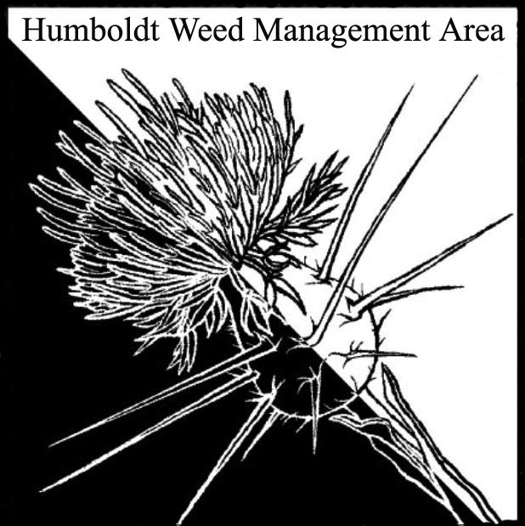
HWMA
Steering Committee Meeting
Monday, March 20, 2017
BLM Large Conference Room
2:00 – 4:00 PM

Minutes

- Welcome: Craig Benson, Interim Meeting Facilitator (1:00)

Introductions (meeting participants): Jennifer Wheeler, BLM; Stassia Samuels, Redwood NP; Bryan Atkinson, Humb Co. Ag; John Summers, MRC; Madeline Hassett, BLM intern; Gordon Leppig, CDFW; Lisa Hoover, USFS; Stephanie Klein, CNPS; Domenic Bongio, Caltrans; Judy Haggard, MLT; Tanya Chapple, MKWC; Craig Benson, NRS-RCAA (facilitator); Amy Eberwein, NRS-RCAA (minutes).

Approval of Minutes: Minutes from May and September 2016 meetings approved pending typo error fixes. Need to be sent to Dana at Cal-IPC to be posted on the WMA web page.

- MOU Membership Update: (1:15)
Jennifer Wheeler confirmed that the process for affirmation by participating organizations has been started. 21 organizations have signed on to continue. Still working on getting affirmation from ~7 organizations. Humboldt County AG is not able to get MOU signed but will still be participating.

Letter of Support Request from Cal-IPC: Request being made for letters of support to Cal-IPC for more $ that can be used towards the HWMA.

- HWMA Leadership: (1:25)
Current funding limits on HWMA leadership. Interim coordinators/facilitators are limited on time they are able to work on HWMA tasks. Bryan Atkinson (Hum. Co. Ag) and Amy Eberwein (NRS-RCAA) volunteered to be co-coordinators contingent upon support from senior members. Stassia Samuels suggested senior members contribute info on how to manage tasks. Craig motioned for Bryan and Amy to be co-coordinators for two (2) years. All in favor.

- Legislative Update: (1:35)
Recent legislation that would have stopped the sale of ivy by nurseries was declined. Stassia will send more information to Amy and Bryan.

- Education Outreach: (1:40)
There are plenty of boxes of the invasive plant guide available for distribution. New co-coordinators need access to master copy of guide for next printing. Jennifer and Domenic will send to Amy and Bryan. WCB project outreach brochures and flyers are available to those who would like them. Contact Amy to request these either in digital or printed form. Outreach materials should be present at upcoming events such as the Del Norte County Plant Show and the Seed and Plant exchange in Humboldt County. The Humboldt County Fair exhibit for HWMA was a successful source for distributing invasive plant info/outreach.

II. Round Robin (informal member reports) (1:50)
Updates from all org’s present:
- Judy Haggard (MLT): Working on weed control (mostly Ivy) with help from CCC’s. Work on Cha-GAH-cho continues. Presented an article by the Mad River Union regarding loss of coastal prairies.
- Bryan Atkinson (HumCo Ag): Monitoring of weed sites will continue soon.
- John Summers (MRC): Five (5) Fee-for-service projects happening now (mostly with Brooms, and some Ivy near the Mattole bridge. Working with mapping programs E-cognition and WHIPPETT to create maps using color signatures to prioritize targets. Will send links to more information on these programs.
- Amy Eberwein (RCAA): Update on status of WCB eradication project. Requests for cost share and monitoring info for participating organizations.
- Madeline Hassett (BLM): New intern to Jennifer Wheeler
- Tanya Chapple (MKWC): Working on oblong spurge, leafy spurge and Italian thistle eradication/control.
- Jennifer Wheeler (BLM): $300K for work on ~Two (2) dozen invasive weeds (internal BLM $) working with CCC’s and MRC. Work locations include several coastal BLM properties, including Trinidad Head for invasive removal and native plantings.
- Gordon Leppig (CDFW): Mostly working on environmental review/permitting and regional conservation planning for large-scale restoration project (~1000 acres) in lower Eel and Eel estuary for Spartina and Ammophila removal. Hoping to shift land management strategies to include biodiversity rather than single species.
- Stassia Samuels (RNP): Working on new EA/programmatic agreement potentially ready next summer. Don’t have complete surveys of the park, therefore can’t dig and must use chemical herbicides. Upcoming blackberry project in Bald Hills. 2000 acres burned last year, will be sprayed this year.
- Lisa Hoover (USFS): No internal funding for invasive plant management. Del Norte has some $ but external funds are running out.
- Stephanie Klein (CNPS): Wildflower Show coming in May. Workdays suffering from low turn out.
- Domenic Bongio (CalTrans): Working on pulling broom from Little Red School House to Piercy. There has been an explosion of brooms due to the wet winter. All knotweed treatments seem to be successful (excepting one location). Diffuse knapweed has been pulled for nine (9) years, currently only four (4) plants left. Stone Lagoon shiny geranium was dug up and transported inadvertently by CalTrans crews to the McDonald road storage yard. Will be moved again to area near Redwood Creek. Domenic plans to keep track of new infestations.
- Craig Benson (RCAA): Spartina treatment in Humboldt Bay now at 400 acres. Need more funding and more people power to deal with expected increase to 700 acres over the few years. Will require 50 people working 200 days per year using all 12 removal techniques. Prop 1 funds obtained.

III. HWMA Meetings and Next meeting (2:25)
- Consensus for set quarterly meetings and maintenance of a calendar of events to avoid missing out on opportunities. Amy and Bryan will work on developing.
- Next meeting set for Monday, June 19, 2017

