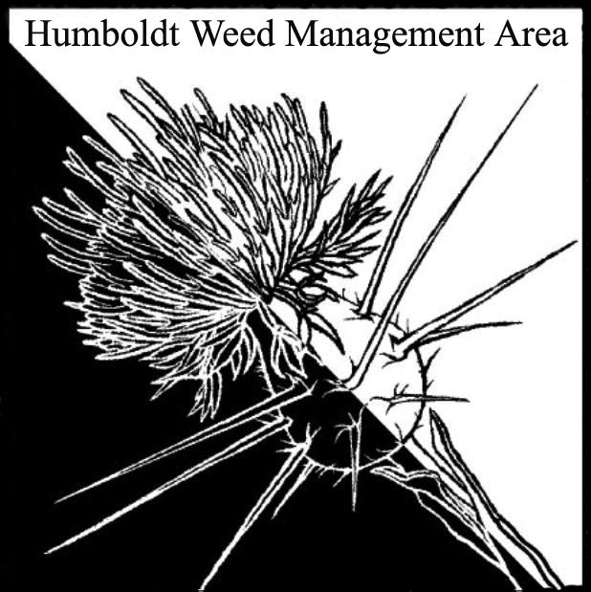
HWMA
Steering Committee Meeting
Monday, September 18, 2017
BLM Large Conference Room
1:00 – 3:00 PM

Meeting Minutes

- Welcome: Bryan Atkinson and Amy Eberwein, Co-Chairs

Introductions (meeting participants): Bryan Atkinson, Humb Co. Ag; Madeline Hassett, BLM intern; Domenic Bongio, Caltrans; Craig Benson, NRS-RCAA, Amy Eberwein, NRS-RCAA; Jenny Hutchinson, USFWS and TCLT; Stassia Samuels, RNP; Laurel Goldsmith, USFWS; Michelle Forys, CSP; Ben Lardiere, Transcon Environmental; Lisa Hoover, USFS; John Summers, MRC; Tanya Chapple, MKWC

Approval of Minutes: Minutes from the last meeting on June 19, 2017 were approved.

Funding update: Our WMA was not invited to submit a proposal for the NFWF Pulling Together Initiative.

- Revising Bylaws: The bylaws will be re-drafted based on edits by steering committee members and sent out prior to the next meeting for a vote. In addition, discussion about inviting Del Norte organizations to join in on meetings. Potential to add them to MOU or create joint WMA in the future.
*Agenda item: Voting in changes to current bylaws
*Action item: Send invitations to our meetings to Del Norte Ag, Smith River Alliance, Del Norte RCD, potentially others.

- Fair Booth Update: Our booth won a “Best of Show” ribbon and we received a $60 check. This year was a great success with hundreds of booklets and info passed out to visitors.

- Ehrharta calycina (Purple Veldt Grass): Michelle Forys is working on treatment of patch located in the Tolowa Dunes. Everyone should keep an eye out for more sites and enter into Calflora if found. Majority of sites are in Marin County, but there are currently 4 known sites in Mendocino.

- Arctotheca calendula (Capeweed): CDFW has been working on eradicating this species in the Eel River Wildlife Area with the help of Laurel Goldsmith and Andrea Pickart. Hoping to renew a county-wide eradication effort. Everyone should enter occurrences to Calflora in case of future funding. Discussion on known locations, fertile vs. infertile varieties (yellow centers = sterile variety Arctotheca prostata), and previous work done. *Action Item: Laurel will visit the Ferndale and Bayside Populations before the next meeting.
*Action Item: Bryan will search for the research folder on this species at Humboldt Ag Dept. Work was previously done with Gary Markegard.

- WCB Knotweeds Update: Before and after photos and review of work that was completed in 2017.

- Round Robin (informal member reports)
  - Amy Eberwein (RCAA)- Knotweeds update 2017. Status of Geranium lucidum sites- all hand pulled at end of summer. Will be continuing to monitoring every couple months to pull re-sprouts.
  - Bryan Atkinson (HumCo. Ag)- Updates on knapweed in Blue Lake. Recently reported Brazillian sponge plant/frogbit in the ponds at CR (freshwater).
  - John Summers (MRC)- Recently dug up an Arundo site. Monitoring in the King Range continues with removal of pampas grass. Scotch broom removal as a fee for service. Where can we get Tansy Flea Beetle?
  - Domenic Bongio (Caltrans)- Two knotweed sites assumed eradicated, the rest are extremely diminished. Crocosmia is now taking over at the 55 mph sign in Orick. Merryman’s knotweed site treated this year. Shining geranium site along the lagoons was scraped and moved in the Dry Lagoon area. Powertool use lawsuit case is being appealed.
  - Lisa Hoover (USFS)- Lots of negative finds of broom in Del Norte county for consecutive years now. No effect on knapweed using mulch in Mad River area. Attempting to integrate invasives into fire fuels plans/restoration.
  - Ben Lardiere (TCE)- Hikshari trail making significant progress on the pampas and fennel removal.
  - Tanya Chapple (MKWC)- Youth crew removed 20 acres of star thistle by hand, timelapse video available on FB. Oblong spurge and toadflax pulls along the river this past spring. No funding for river work next year or for private properties. Decrease in volunteers. No access to some sites due to fires.
  - Michelle Forys (CSP)- Floated for purple loosestrife (38 miles), cut and/or pulled. Decrease in numbers (11th year). Need funding for more of this work. Potentially no more after this year. New tamarisk site found- will spray after CEQA is complete, pulling until then. North of Miranda- found Tree of Heaven. Arundo 4 small sites on private property at Myers Flat. Geranium moving into parks from Caltrans sites. 2 resprouts of knotweed at the maintenance yard (treated). Need assessment up creek from Immortal Tree for Giant knotweed. Bulldozing beach grass. *Agenda item: Potential work with Redwood Rangers group to contact nurseries and do outreach for Green Gardening brochure.
  - Laurel Goldsmith (USFWS)- Continuing work on star mustard removal in Manila once a month, numbers are down. Potential for monitoring needed on Lupin Ave.
  - Stassia Samuels (RNPS)- Broom in 15 years has gone from 3500 to 300 hours of work by hand pulling. Bald hills ox-eye daisy/blackberry project delayed by smoke. We should start worrying about Fennel! Strawberry creek Mana grass expansion. EA from 2012 goes public in Oct/Nov for invasives plan. Please submit comments in favor of herbicide use. Will send info.
  - Craig (RCAA)- Spartina update- when tides are right, treatment occurs. 350 acres treated this year. Need to increase crewmembers. Mulch experiments with yellow star thistle.
  - Jenny Hutchinson (USFWS/TCLT)- Helping with star mustard removal. TCLT gallfly released about a month ago. Will update when more information is available.
  - Madie Hassett (BLM)- Trinidad head ivy and pampas removal success. Upcoming workday for planting natives.

III. Next HWMA meeting
Next meeting set for Tuesday, January 16, 2017 from 1 – 3 p.m. at the Arcata BLM field office.

